A neural networks approach to changes in European corporate communications in the wake of Fridays for Future

Masterarbeit

zur Erlangung des

Mastergrades

der Kultur- und Sozialwissenschaftlichen Fakultät der

Universität Luzern

vorgelegt von

Fabio Keller

16-309-098

Eingereicht am:

Erstgutachter*in: Prof. Dr. Sophie Mützel

Zweitgutachter*in: Dr. Gerret von Nordheim

# Statement of authorship

I have used no other sources and aids other than those indicated. All passages quoted from publications or paraphrased from these sources are indicated as such, i.e. cited or attributed. This thesis was not submitted in any form for another degree or diploma at any university or other institution of tertiary education.

Fabio Keller, <date>

# Acknowledgements

Prof. Dr Sophie Mützel

Dr Gerret von Nordheim, a researcher at the University of Hamburg, provides the tweets. He has academic access to the Twitter API and kindly offered to scrape the data.

Stanik et al. for providing the replication package

Fridays for Future

Towards data science

# Abstract

Purpose

Design/Methodology/Approach

Findings

Research limitations/implications

Originality/value

Keywords

Paper Type

Table of contents

1. Statement of authorship 2

2. Acknowledgements 3

3. Abstract 4

4. List of figures and tables 6

5. Introduction 7

6. Background 9

6.1 Legitimacy theory 9

6.2 Major social incidents and movements 10

6.3 Determinants of sustainability communication? 12

7. Approach 16

7.1 Data 16

7.2 Preprocess 19

7.3 Embedding and clustering 20

8. Results and discussion 24

8.1 Overall protests and tweeting 24

8.2 2B or not 2B 26

8.3 Nations, Transnational FFF and multinational companies 30

9. Conclusion 33

10. Bibliography 36

Appendix A: Forbes Global 2000 37

Appendix B: Code 42

# List of figures and tables

Figure 1: Visualised Approach 16

[Figure 2: UMAP Plot of Embeddings in two-dimensional space 22](https://d.docs.live.net/c7b7ec107e61ac50/07_Uni/master_thesis/output/Keller_Fabio_MA-Arbeit.docx#_Toc99918784)

Figure 3: Overall share of corporate tweets on the topic of sustainability 24

Figure 4: Protesters in selected European countries per week 25

Figure 5: Number of tweets per Topic per Context before and after FFF protests 27

Figure 6: B2B and B2C companies’ overall shares of sustainability tweets per week 27

Figure 7: Shares of sustainability tweets in European countries with more than 25 companies on the Forbes list 30

Table 1: Random Sample of Forbes Global 2000 European Companies with corresponding Twitter IDs 17

Table 2: FFF protesters in selected European countries per week 18

Table 3: Most frequent words in clusters found by HDBSCAN 22

Table 4: B2B and B2C companies’ tweets related to sustainability 28

Table 5: Regressions of sustainability share on protest size per country 31

# Introduction

On September 20th, 2019, Fridays for Future (FFF) held the largest climate protest ever (Laville and Watts 2019). Several million people took to the streets to demand a limit to climate change. The movement, especially its founder and icon, Greta Thunberg, received immense media attention on that day and the year leading up to it. FFF brought climate change and sustainability to the forefront of the political agenda (Marquardt 2020) and pressured large companies to decarbonise the economy. Some corporations did not take long to react. The German car manufacturer Volkswagen, for example, displayed a large picture of Thunberg on its website and wrote that it was firmly committed to the 2015 Paris Agreement (Schenten 2019). Ironically, the agreement was signed in the same year that the company attracted attention through a major diesel scandal.

Volkswagen’s behaviour is typical of companies that see their legitimacy threatened. Research has shown that adverse events like oil spills trigger a strategic disclosure reaction to avert the loss of legitimacy (C. M. Deegan 2019). Legitimacy is essential for every company because it gives recognition and helps sell more products (Kwak, Zhang, and Yu 2019). However, it is unclear if and how this mechanism applies to large, long-term social movements. Movements of this scale have the potential to redefine what legitimacy means for not just a single company but almost any business model.

Was Volkswagen an exception, or did companies across the board adapt their communication? What about corporations whose names are less familiar and who operate, for example, in the mining or chemicals sectors? How deeply has FFF’s message penetrated the business world? This knowledge is important because FFF’s message affects companies that mainly have other companies as customers (Business-to-business or B2B), perhaps even more than those well-known brands directly supplying consumers (B2C). B2B firms often work at the beginning of the value chain where greenhouse gas emissions originate. According to current knowledge, we must assume that B2B companies will react rather restrainedly (Iankova et al. 2019; Swani, Brown, and Milne 2014). However, this is by no means certain since research on sustainability in B2B firms has been neglected (Brennan 2014).

How companies react to FFF probably also depends on the type of economy and the culture of the country they operate. Research shows that firms in market-oriented countries are less likely to maintain complex networks with civil society (Hall and Soskice 2001). The salience of certain cultural aspects also influences how much companies care about sustainability (Vachon 2010). In other words, it could be that Volkswagen being German is one of the reasons for the company’s swift reaction to FFF. But it is an open question what role the national context still plays when a transnational movement challenges multinational companies.

This research examines the relationship between the size of FFF protests and corporate sustainability communication. A set of tweets by the largest European companies from the end of 2017 to 2019 serves as input to model the latter variable. A deep bidirectional natural language processing algorithm creates representations of all tweets, later reduced and grouped into clusters. The clusters correspond to topics in tweets. This approach is superior to more traditional topic classification algorithms because it does not assume a predefined cluster size, considers context and synonyms and does not force tweets into categories.

This study makes several contributions. First, it applies a new, relatively sophisticated computational method to a social sciences problem without significant financial or human resources. The study shows that barriers to using Deep Learning for social sciences are relatively low. Second, the dataset created and analysed by this research is publicly available. The algorithm detected more topics besides sustainability that could be used to address a variety of research questions. Third, this research shows that companies tweeted more about sustainability in the wake of FFF. There is a positive correlation between protest size and relative sustainability tweets, especially during the largest protests in September 2019. Fourth, B2B companies, surprisingly, tweet more about sustainability than B2C companies and are only marginally less active on Twitter. However, B2C companies are more sensitive to FFF protests. Their share of sustainability tweets correlates more with the size of protests. Fifth, this study shows that firms from Sweden, a typical Coordinated Market Economy (CME), and firms from France, an individualistic country that tends to be a CME, tweet more about sustainability and are more sensitive to protest size.

FFF can benefit from this research by better understanding how their protests affect companies. The movement could adjust its strategy accordingly and target individual countries or sectors. Companies can use the findings to understand external influences on communication behaviour and create self-awareness, which could help communication agendas become more targeted and less impulsive. Consumers can see that strategic disclosure offensives, such as Volkswagen’s, are nothing out of the ordinary but part of a systematic response to changes in the social context.

# Background

## Legitimacy theory

### Motivations for disclosure

Legitimacy theory states that there is a social contract between firms and society. While society provides natural resources, employment and infrastructure, companies produce goods and services and align with society’s value system. When a company delivers an adequate economic output and bears its social and environmental responsibility, it is said to be legitimate. Legitimacy is, therefore, a state of congruence between the company and the social system of which it is a part (Mousa and Hassan 2015). More fundamentally, legitimation is the process whereby an organisation justifies to a peer or superordinate system its right to exist (C. Deegan and Rankin 1996; Maurer 1971; Silva 2021).

Companies want legitimacy because it increases acceptance and recognition, and it helps to mobilise resources and acquire political strength (Aldrich and Fiol 1994). They also regard it as an asset that contributes to economic success and helps to establish new products (Kwak, Zhang, and Yu 2019). The second motivation to gain legitimacy is particularly interesting because it also involves companies that act primarily for profit. However, it requires that other market participants demand legitimacy to purchase a product.

Legitimacy is not given but formed through conscious actions (Bergek, Jacobsson, and Björn A. Sandén 2008). According to Fleming and Jones (2012), companies take environmental, social, and governance (ESG) measures to attain legitimacy. Whether these measures involve true transformations or are merely superficial is secondary. What counts is the company’s public perception, which is shaped by disclosures and communication (Prado-Roman, Diez-Martin, and Blanco-Gonzalez 2020). Companies disclose social and environmental information to manage their image so that stakeholders perceive them as congruent with the social system’s values (C. M. Deegan 2019). Social and environmental disclosures aim at legitimation and the establishment of a reservoir of goodwill toward the company.

According to Alrazi et al. (2015), “environmental legitimacy is conditional upon the public evaluation of corporate environmental performance and reporting.” Thus, environmental legitimacy is only indirectly related to the company’s actual environmental performance. Legitimacy is also achievable when the public positively re-evaluates a company even though its actual impacts did not change or only changed marginally (Berrone, Gelabert, and Fosfuri 2009). Oliver (1991) suggests that “the appearance rather than the fact of conformity is often presumed to be sufficient for the attainment of legitimacy”, which, again, shows the importance of sustainability communication.

### Channels of disclosure

The most important vehicle for legitimacy-relevant information has long been either a company’s annual report - with a section dedicated to sustainability - or, more recently, a standalone sustainability report. Much research has focused on these conventional channels, while relatively newer ones have been neglected (C. M. Deegan 2019). Researchers from the Sumy State University in Ukraine show in their case study how firms, especially since the financial crisis of 2008, communicate sustainability information more widely and also see it as a marketing tool to attract investment and generate higher sales (Vasylieva et al. 2017). This realignment requires companies to use new channels to reach various interest groups.

Companies increasingly use social media to disseminate sustainability information and attain legitimacy towards various interest groups (Hassan and Guo 2017). Social media are particularly well-suited channels because they enhance stakeholder engagement, enable a more direct dialogue and democratise access to information. Social media are a fast way of managing public expectations (Nwagbara and Reid 2013). Due to its unique characteristics, Twitter is particularly appropriate to engage the public. 96% of Fortune 500 companies have an active Twitter account, which is higher than any other social network (Barnes, Mazzola, and Killeen 2020). Its range of users, from individuals to corporations, media, NGOs and governments, is uniquely broad (Stieglitz and Krüger 2011). Since its launch in 2006, Twitter has turned from a niche service to a modern public square with more than 300,000,000 users. The social network has become an important channel to express opinions (Merle, Reese, and Drews 2019). Although the developers have added more features over time and adapted the design, Twitter has not fundamentally changed; short, uniform messages sent by users in microblogging format remain its essence (Weller et al. 2014). Consistency, uniformity and simplicity set Twitter apart. Araujo and Kollat (2018) find that sustainability-related tweets are likelier to generate user interaction than tweets on other topics. They recommend that companies build up a strong Twitter presence even if they only pursue their self-interest.

## Major social incidents and movements

Hoogiehmstra (2000) states that companies whose legitimacy is threatened by public pressure and media attention following social upheavals or environmental incidents react by increasing coverage of environmental issues in annual reports. Deegan (2019) emphatically confirms this finding: “(…) significant, adverse social events involving an organisation, or an industry to which it belongs, will evoke a legitimising and strategic disclosure reaction (…).” Both refer to research that analysed corporate reporting in the wake of relatively isolated events like oil spills or intense media coverage of inadequate working conditions. Early examples include Walden and Schwartz (1997) and Brown and Deegan (1998). Social or environmental incidents acutely threaten the legitimacy of a company. It responds by communicating information to realign its perception with society’s priorities. (Berrone, Fosfuri, and Gelabert 2017).

There is, however, only a little research on corporate communication in the wake of large-scale social movements that last over a more extended period. Unlike isolated events, such movements do not merely question whether a specific company is aligned with society’s value system but rather challenge and potentially shift the system at large. Social movements of this magnitude are relatively rare, which may be one of the reasons why there is little research. Another reason may be the methodological difficulties of quantifying such movements and companies’ reactions.

### Fridays for Future

In August 2018, Swedish teenager Greta Thunberg began a school strike in front of the Swedish parliament to demand more action on climate change. Her lone protest developed into a global movement with the “Fridays for Future” banner. Due to its unprecedented size and duration, FFF became a turning point in global climate activism. At its peak date in September 2019, FFF mobilised more than 6,000,000 people worldwide. The movement’s founder and icon, Greta Thunberg, received extensive media coverage throughout the year and attended high-level international political meetings worldwide. No previous organised youth movement achieved a comparable level of attention (Wahlström et al. 2019).

FFF has significantly increased social awareness of climate change, and it has left its mark on society and the political agenda of several countries. By questioning economic growth per se, FFF sparked fundamental political debates about divergent visions for the future (Marquardt 2020). While it is too early to assess the long-term impact of the movement, it has been able to sensitise society to the urgency of its concern. This led to at least a short-term shift in the value system and challenged the legitimacy of any business model based on resource depletion and indefinite growth.

FFF’s primary demand is to keep global temperature rise well below 1.5 degrees Celsius compared to pre-industrial levels (Fridays for Future 2022). The movement often refers to the 2015 Paris Agreement, which calls for limiting global warming well below 2 and preferably 1.5 degrees to avert severe consequences (United Nations 2022). Greenhouse gas emissions must be reduced to achieve the goal. Therefore, fossil fuels must be replaced by more sustainable alternatives. This research derives its understanding of sustainability from FFF’s primary demand. Sustainability is understood relatively narrowly as avoiding the depletion of natural resources to maintain an environmental balance and limit climate change.

The question arises as to how companies react to a movement that fundamentally questions their business models, if not the entire market economy. This research predicts that the relationship Hooghiemstra (2000) and Deegan (2019) found between isolated social events and annual reports also applies to a social movement and Twitter communication. Accordingly, companies will generally increase communication on the topic during the end of 2018 and 2019 and respond to particularly large protests with particularly intensive strategic and legitimising disclosure reactions.

**H1**

Companies started tweeting more about sustainability in the wake of FFF.

## Determinants of sustainability communication?

### B2B and B2C context

Swani et al. (2014) put corporate communication on Twitter into perspective. They show that the context of a company, namely whether it has a B2B or a B2C model, can strongly influence its behaviour. B2B firms use Twitter less and generally have less sophisticated communication strategies on social media. Iankova et al. (2019) add that B2B companies consider social media a less important channel than B2C companies. The former probably considers communication via Twitter to be less effective. One reason for these different assessments could be that B2B managers assess the risks and benefits of social media differently.

Social movements may not reflect as much in the communication behaviour of B2B companies on Twitter. This assumption is plausible because movements consist of individuals, which B2B companies are naturally less likely to address. B2C companies, on the other hand, may feel more pressure to obtain legitimacy from civil society because they directly cater to consumers. Since the general population tends to know their names and brands better, B2C companies may have a greater need to be seen as legitimate by social movements.

However, the expected difference concerning Twitter does not mean that B2B companies generally communicate less about sustainability or consider the issue less important. Rudawska (2019) compares small and medium-sized B2B and B2C enterprises in Europe. She shows that both groups work hard to legitimise themselves by communicating sustainability efforts to various stakeholders. The only significant difference relates to promoting sustainable consumption. Surprisingly, this is more frequent among B2B companies. While these findings relativise the assumption that B2B companies communicate less on sustainability, their behaviour on Twitter and especially their reaction to a social movement are still likely to be attenuated due to the greater distance to the end consumer.

**H2a**

Overall, B2B companies communicate less about sustainability on Twitter.

**H2b**

B2B companies are less sensitive to social movements like FFF regarding their communication behaviour.

### National context

Legitimacy refers to a situation where the actions and values of a company are in line with the overarching value system of society. However, which society is meant? Value systems vary across space, traditionally between local, regional and national communities. Therefore, the type of legitimacy and the modalities of legitimation depend on the country in which a company was socialised and where it operates.

Hall and Soskice (2001) try to answer whether firms in different nations have systematic differences in their structures and strategies. Their central premise is that business structures and priorities fundamentally depend on the regulatory and economic framework, which is, in turn, mainly shaped by the state and the nation a firm operates in. Two ideal types delimit a spectrum of market economies: the Liberal Market Economy (LME) and the Coordinated Market Economy (CME). Hall and Soskice (2001) call this model “Varieties of Capitalism”. In LMEs, firms “coordinate their activities primarily via hierarchies and competitive market arrangements.” Companies base their choices on marginal calculations, which neoclassical economists emphasise. With its decisive forces of supply and demand, the market coordinates interactions between firms and society. In CMEs, by contrast, firms “depend more heavily on non-market relationships to coordinate their endeavours with other actors.” Companies have more collaborative than competitive interactions and more heavily depend on complex networks of various actors. Employees of CMEs are typically more unionised, and state policies encourage information sharing and collaboration between firms. A typical European example of an LME is the UK. Typical CMEs are Sweden and Scandinavian economies. France and southern European economies are often characterised as hybrid types, while the German economy is relatively hard to classify on this spectrum.

Varieties of Capitalism does not directly address corporate communication strategies, but it stands to reason that CMEs would interact more with non-business actors like FFF. Sustainability could simply be more relevant for companies in CMEs. However, sustainable solutions are in demand. Market participants increasingly want greener alternatives, so companies in LMEs must also care about it. It can make sense from a purely rational point of view to respond to the demands of a protest movement. Moreover, according to the model, firms in LMEs are more likely to produce disruptive innovations, which is a vital asset in communication campaigns. Therefore, it is not clear a priori which type of economic system promotes sustainability communication.

Instead of examining the type of economy firms operate in, Vachon (2010) considers the national culture determinant. He examines the link between national culture and corporate sustainability practice. He uses Hofstede’s (2011) model to distinguish cultures, which originally characterised countries along four cultural dimensions: power distance, uncertainty avoidance, individualism, and masculinity-femininity. Individualism means that people look after their personal development and close family members. Belonging to a group or a family in a broader sense is more important in collectivist cultures. Uncertainty avoidance refers to the tendency of a culture to minimise and capture risks through rules, regulations and standards. Vachon (2010) finds that countries with high individualism and high uncertainty avoidance tend to have green corporatism, environmental innovation, fair labour practices and corporate social involvement. Companies from individualistic cultures could be more inclined to challenge the status quo by denouncing it and pushing an environmental agenda because individual initiatives are likelier to be encouraged. The reasoning behind the link between uncertainty avoidance and environmental action is contradictory. On the one hand, risk-averse companies might be more likely to respond to protesters’ demands. On the other hand, the ecological transformation also brings many changes and thus uncertainties (Vachon 2010).

Soerensson et al. (2019) investigate how national culture influences corporate sustainability communication. They qualitatively examine 100 large European corporations and use Hofstede’s (2011) characterisation of the Netherlands, France, Germany, Sweden and Finland to outline national cultures. Soerensson et al. (2019) find evidence that culture is indeed relevant in the environmental domain of sustainability communication. Companies in France and Germany value certificates, rules and standards in their effort to transform operations. They consider formal structures necessary for legitimacy and take a long-term perspective. Soerensson et al. (2019) show that uncertainty avoidance and individualism are features of French - and to a lesser degree German - culture which might explain companies’ handling of environmental challenges. These results are consistent with Vachon (2010).

France ranks highest in power distance and uncertainty avoidance, and the French economy is a partial CME. Hence, its companies will probably strongly respond to protest movements. Although firms in LMEs might also respond to FFF demands, this research assumes that a typical Nordic CME such as Sweden’s will address this more intensively. In the case of FFF, this might be particularly true since the movement originated in Stockholm. German companies will communicate slightly above average on sustainability, while Southern European and British companies will pay less attention. Whether there are any significant differences in a globalised world with multinational companies confronted with a transnational movement is not certain and remains an open question.

**H3**

French and Swedish companies are likely to tweet most about sustainability in the wake of a social movement raising corresponding demands.

# Approach

The basic idea is to depict the reaction of European companies to FFF by analysing their sustainability communication on Twitter. The approach takes a set of tweets from European companies as input and cleans and translates them. Then, a deep learning algorithm creates a high-dimensional vector representation for every tweet. Dimensionality reduction later reduces the vector to its most essential components. Finally, a clustering algorithm finds topics in the tweets, which makes it possible to create a communication profile for each company at every point in time. Figure 1 illustrates the process schematically. Names and abbreviations contained in icons will be explained in detail.

Figure : Visualised Approach

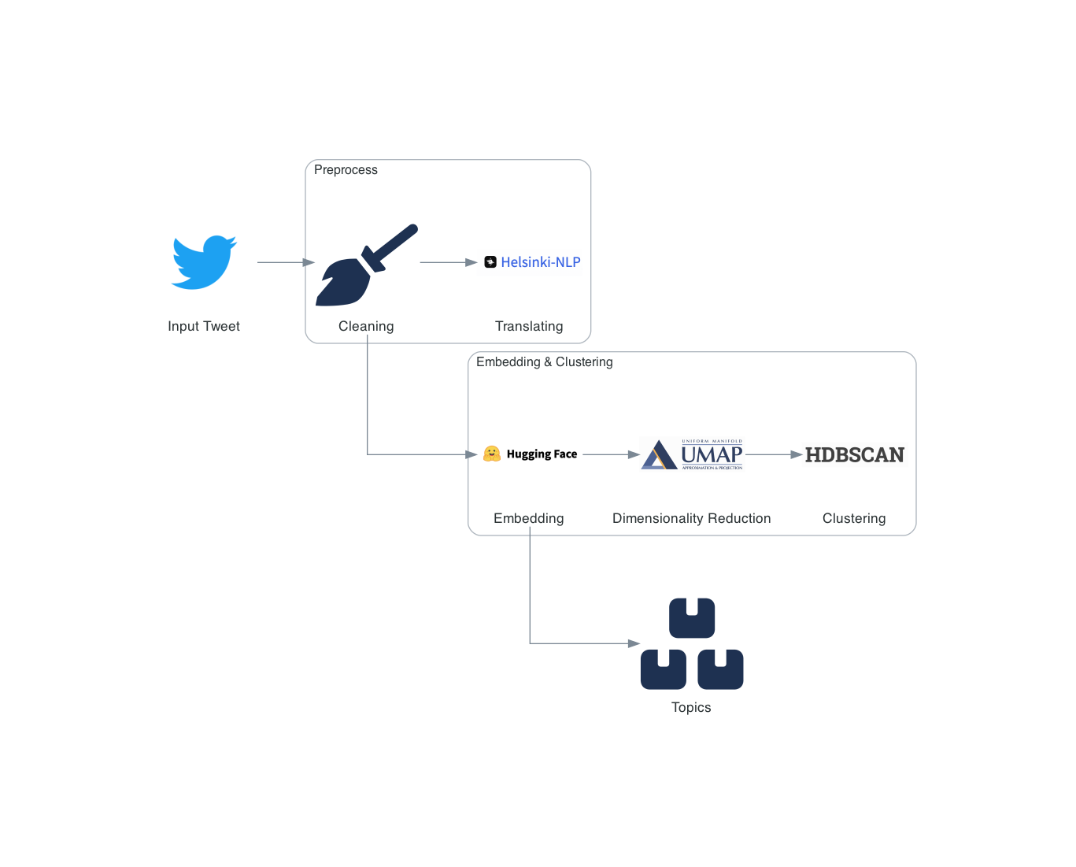

## Data

### Forbes Global 2000

The Forbes media company publishes an annual list of the World’s 2000 largest companies called the “Forbes Global 2000”. Companies are screened according to four metrics: sales, profits, assets and market value (Murphy 2015). The website “data.world” provides most annual editions of the list to download (dataworld 2021). This research chooses the 2019 version because of the Twitter data period (see 8.1.3). All European companies, 434 in total, are filtered from the list. This set represents Europe’s largest companies. Table 1 shows a random extract of the Forbes list. The entire list is in the appendix.

Table 1: Random Sample of Forbes Global 2000 European Companies with corresponding Twitter IDs

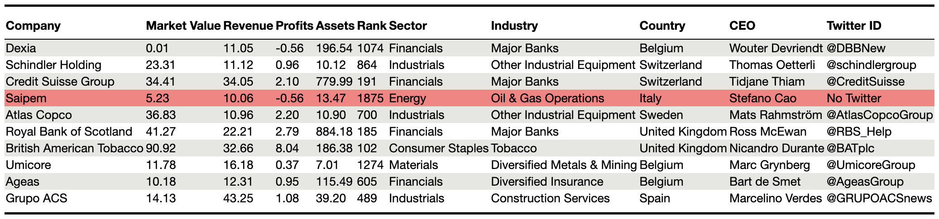

The Twitter IDs were manually searched on Twitter. Of all companies with a Twitter account, eight did not have a group Twitter account in December 2021. Daimler, for example, only has accounts for its respective brands, like Mercedes-Benz or MINI. In this case, the brand’s account with the highest turnover was selected. If the company did not have an international account, this research chose the national account for the country where the company has its headquarters. Marked in red and with “No Twitter” are all companies that no longer existed, only maintained Twitter accounts for overseas markets, have switched the account to private or simply did not have a Twitter account.

Forbes divides the companies into sectors and industries, but the list does not specify whether a company is B2B or B2C. In many cases, a clear demarcation is difficult to establish because multinational companies often have both types of customers, business and consumer (Iankova et al. 2019). Additionally, the context of digitalisation and social media tends to blur the distinction between consumer and business customers (Nath, Saha, and Salehi-Sangari 2019). Surprisingly, the academic papers examining differences between B2B and B2C firms hardly address the definition or distinguishing features of the two groups (Iankova et al. 2019; Silva 2021; Swani, Brown, and Milne 2014; Zhang and Du 2020). As a result, there is no formal, consensual definition. However, all texts implicitly assume that B2C refers to the process of selling goods and services directly to the end-user, which means that B2C companies are often at the end of the value chain. B2B, by contrast, means selling goods and services that are subsequently processed by other companies, which is a transaction at the beginning or in the middle of the value chain. Firms in the Materials and Industrials sectors, as defined by Forbes, operate predominantly at the beginning and middle of the value chain. Firms in the Consumer Staples and Consumer Discretionary sectors operate at the end. Some industries within these sectors do not follow this rule. These industries were identified and excluded. Otherwise, the groups B2B and B2C correspond to the sectors mentioned. The details of the classification are in the appendix. There are 71 B2B and 67 B2C companies. All other companies are not forced into a group because firms in sectors like Financials or Information Technology are hardly ever either B2B or B2C, but primarily hybrid.

### FFF protests

The data on FFF protests come from the movement itself. Upon email request, this research was given access to spreadsheets documenting the size and location of all protests. As shown in Table 2, the first significant protest occurred at the beginning of September 2018, with more than 4500 participants in Europe. Much of the data, if not all, are publicly accessible on the movement’s website (Fridays for Future 2021). It is not possible to ensure that all numbers are accurate. However, it is plausible that they, at least, reflect the protests’ relative size. The highest figures, for example, in September 2019, correspond to the media reports (Laville and Watts 2019), which makes them credible.

The original data have a column for each Friday of protest and a row for each country where protests occur. This research reduces the countries to those from which companies are represented in the Forbes list, transforms the exact dates into weeks of the ISO calendar, and focuses on the Twitter data period (see 8.1.3). This process of modifying the original data and all processes described later in the text can be reproduced with the code in the appendix.

Table 2: FFF protesters in selected European countries per week

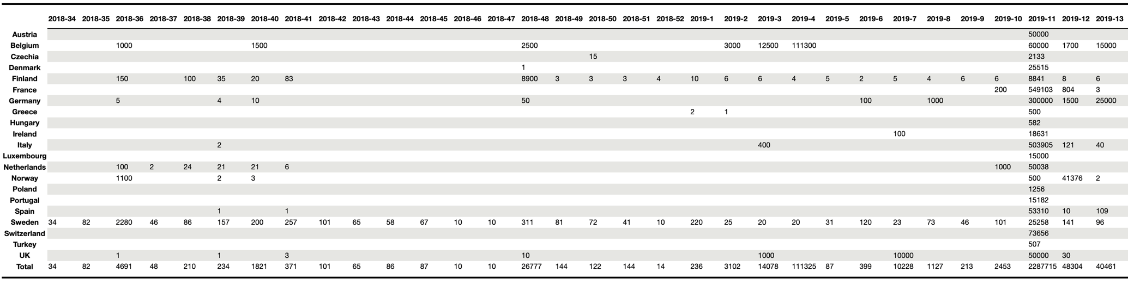

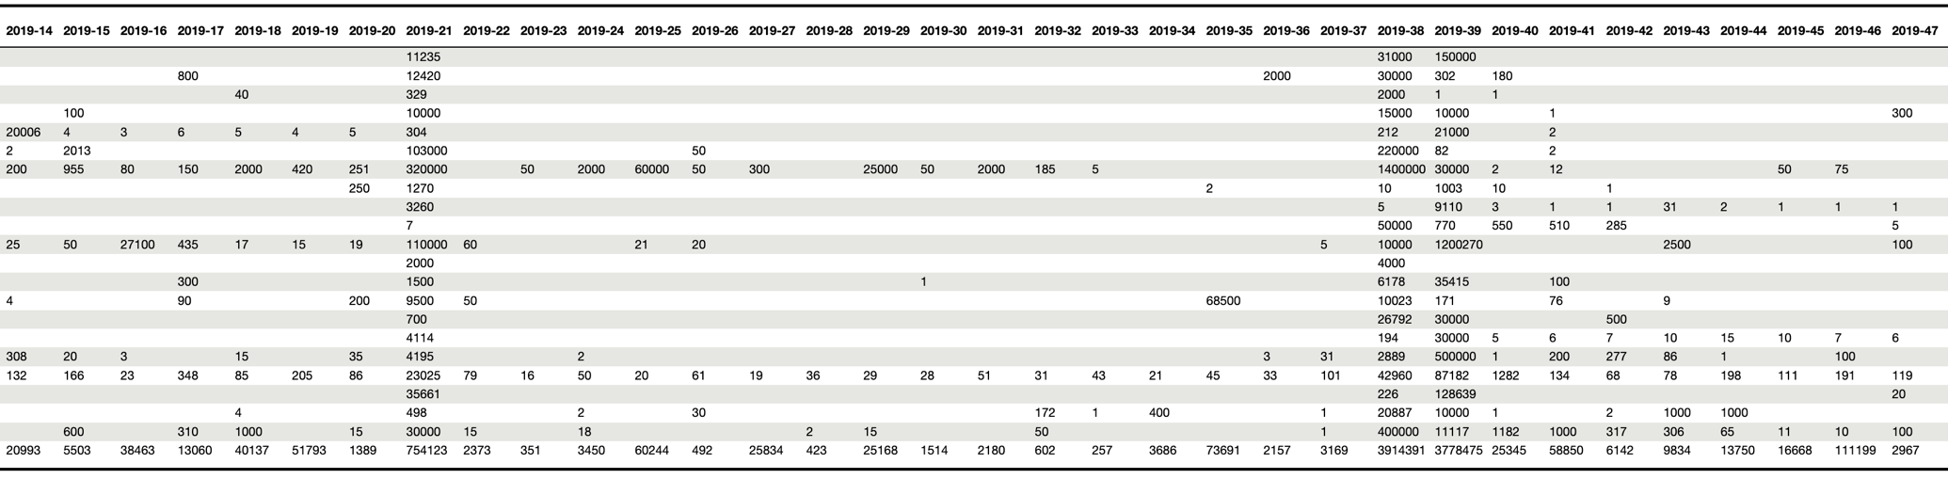

### Corporate tweets

Twitter provides special academic access to its API, with which it is possible to download large quantities of tweets, including metadata. This research chooses to analyse all tweets made by European companies in the 2019 Forbes Global 2000 list from approximately one year before and after the first large FFF protests. The exact period is 1.12.2017 to 30.11.2019. Mainly economic considerations influence this decision. It would go beyond the scope of this research to examine a more extended period because, with more tweets, the time and financial costs for the analysis would increase substantially.

The API returns around 2,500,000 tweets for the period. In a preliminary phase, this research sorts out irrelevant data. First, only critical variables are kept: the tweet’s author, its ID, date, language, type, and the text itself. Then, all non-organic tweets are filtered out for logical and economic reasons. Twitter differentiates four types: First, organic tweets are messages created by a given user. Second, retweets are messages taken from another user and posted on a given user’s profile. Third, quotes are retweets to which a given user adds additional content. Fourth, replies are messages that directly respond to another user’s tweet. Replies are largely irrelevant in studying high-level corporate communications because many companies use them as a customer services tool to handle inquiries. Also, replies account for about 75% of all tweets in the dataset, so excluding them saves resources. Retweets and quotes are also excluded because these formats echo other users more than they carry a given user’s genuine message.

## Preprocess

This section explains the systematic modification of every tweet to optimise topic classification. Consider the following tweet as an example:

**#ArtContemporain2022 s’annonce prometteuse pour les amateurs d’art ! Pour y voir plus clair, zoom sur notre sélection des expositions incontournables de cette nouvelle année. http://collectionsocietegenerale.com/fr/actualites/peinture-dessin-photographie-10-expos-incontournables-en-2022-2263.html…@Collection_SG** [**#nosartistessontpartout**](https://twitter.com/hashtag/nosartistessontpartout?src=hashtag_click)

### Hashtags, URLs, mentions and other filters

A hashtag is one or multiple keywords prefaced by the hash symbol. It qualifies posts thematically and, therefore, contains information relevant to this research. The example tweet contains two hashtags: #ArtContemporain2022 and #nosartistessontpartout. It is difficult to deal with them because sometimes several words are combined into one. This research handles this with a word separator trained on tweets. It systematically searches hashtags, splits them into their word components - if they consist of several words - and appends the components to the end of the tweet to preserve information.

Next, this research identifies and removes URLs, numbers, and Twitter accounts a given tweet addresses with expressions like @Collection_SG. This step is a standard procedure (Stanik, Pietz, and Maalej 2021) because these components could falsify a classification algorithm. For example, the algorithm might understand a URL or a number as a word and define related themes.

The tweets are filtered further due to conditions imposed by the translation method (see 8.2.2). This research excludes languages with less than 100 tweets and languages that are undefined or written with a non-Latin alphabet. Also, authors with less than 100 tweets are discarded. 360’000 tweets remain after filtering the original 2,500,000.

### Multiple languages

This research includes non-English tweets for a more representative outcome, which means translating roughly 100,000 tweets with an average of 179 characters. Fulfilling this task at December 2021 rates would cost around EUR 300 with leading service providers DeepL or Google Translate. In order to save costs and support open-source approaches, this research mainly uses algorithms made freely available by the University of Helsinki via the Hugging Face platform (University of Helsinki 2021). The University of Helsinki provides one model capable of translating all Roman languages, namely Portuguese, Spanish, Italian, French and Catalan, and individual models for each of the following: German, Swedish, Danish, Turkish, Finnish, Polish, Estonian and Dutch. The only languages without open-source Helsinki models are Norwegian and Latvian. Those are translated automatically with the DeepL API.

All preprocessing yields the following result from the above example tweet:

***art contemporary promises to be a promising year for art lovers to get a clearer picture lets zoom in on our selection of the must-see exhibitions of this new year our artists are everywhere.***

## Embedding and clustering

This research relies on a recent paper published by the University of Hamburg to model the tweets’ topics. Stanik, Pietz and Maalej (2021) represent tweets with high-dimensional vectors using a deep bidirectional natural language processing algorithm. Then, they reduce dimensionality and cluster the vectors to find human-understandable topics with an algorithm called Uniform Manifold Approximation & Projection UMAP. Their approach does not require predefined critical parameters like the number of clusters. It achieves an agreement level of around 90% with human coders, which is especially remarkable for short texts. Stanik, Pietz and Maalej’s (2021) approach is superior to traditional topic modelling algorithms like bag-of-words, TF-IDF or LDA. The methodology is basically transferable to this research’s problem. However, the method was slightly adapted due to the specific data, other computational infrastructure, and new, more advanced neural networks.

The main challenge is to automate the task of assigning a topic to every tweet. As a first step, Stanik, Pietz and Maalej (2021) propose constructing a high-dimensional representation, sometimes called “sentence embedding”, for each tweet. A neural network outputs a 768-dimensional vector that functions as a semantic representation of a given input text. The cosine distance between two vectors is analogous to the thematic similarity between two texts. For example, the embeddings of the two sentences “We love travelling around the globe.” and “We enjoy roaming the planet.” would be relatively close in high-dimensional space. The proximity in space reflects that the two sentences mean almost the same thing. The system recognises synonyms which is an essential feature when dealing with short texts. It is a significant advantage over other approaches such as bag-of-words and TF-IDF. An accumulation of sentence embeddings in high-dimensional space represents a topic.

To create sentence embeddings, this research uses the (sentence-transformers/all-mpnet-base-v2 n.d.) model instead of the (sentence-transformers/bert-base-nli-mean-tokens n.d.) checkpoint of BERT used by Stanik, Pietz and Maalej (2021). According to the package’s documentation, the latter is out of date as of December 2021. The newer model is supposed to achieve better results, but the underlying principle remains the same.

It would be possible to calculate the distances between hundreds of thousands of vectors in high-dimensional space. That would, however, cost a lot of computing power and add little value because many of the 768 data points are redundant when trying to find human-understandable topics. Following Stanik, Pietz and Maalej (2021) this research uses the UMAP (McInnes 2018) algorithm to reduce dimensionality to ten, which is a relatively low number that helps spare memory. Stanik, Pietz and Maalej (2021) choose 20 as a hyperparameter but explain that this setting only has little influence on the result. The number-of-neighbours hyperparameter is set to 100 instead of 400 for the same reason. The impact of this adjustment on the quality of the results is difficult to assess. However, switching from 50 to 100 had almost no effect.

The final step involves the HDBSCAN algorithm, a clustering technique that identifies accumulations of points representing topics in a corpus of documents. Contrary to other clustering algorithms, HDBSCAN does not require a predefined number of topics, does not force data points into clusters, does not assume a cluster shape and can find clusters with different point densities. Consistent with Stanik, Pietz and Maalej (2021), this research chooses 30 as the smallest cluster size and the “leaf” selection strategy, which favours smaller clusters. Furthermore, 7000 is chosen as the minimum cluster size to account for the dataset’s size. Figure 2 is a two-dimensional simplification of what the above process has calculated. Every dot on the graph represents a two-dimensional vector that is a reduction of the original 768-dimensional vector representing a given tweet. The numbers and colours in the legend correspond to the found topics. Table 3 shows the ten most frequent words per topic, calculated with the TF-IDF method (see code in the appendix).

Figure : UMAP Plot of Embeddings in two-dimensional space

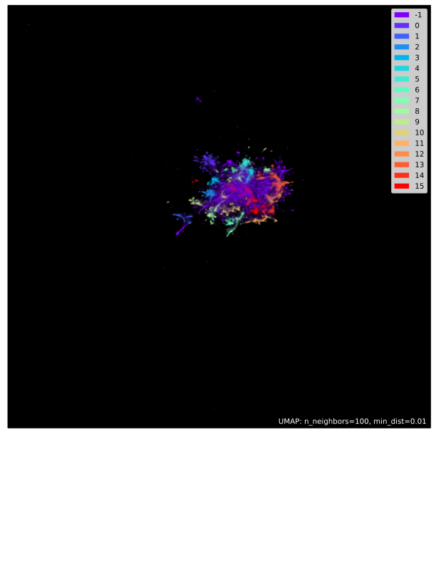

Table 3: Most frequent words in clusters found by HDBSCAN

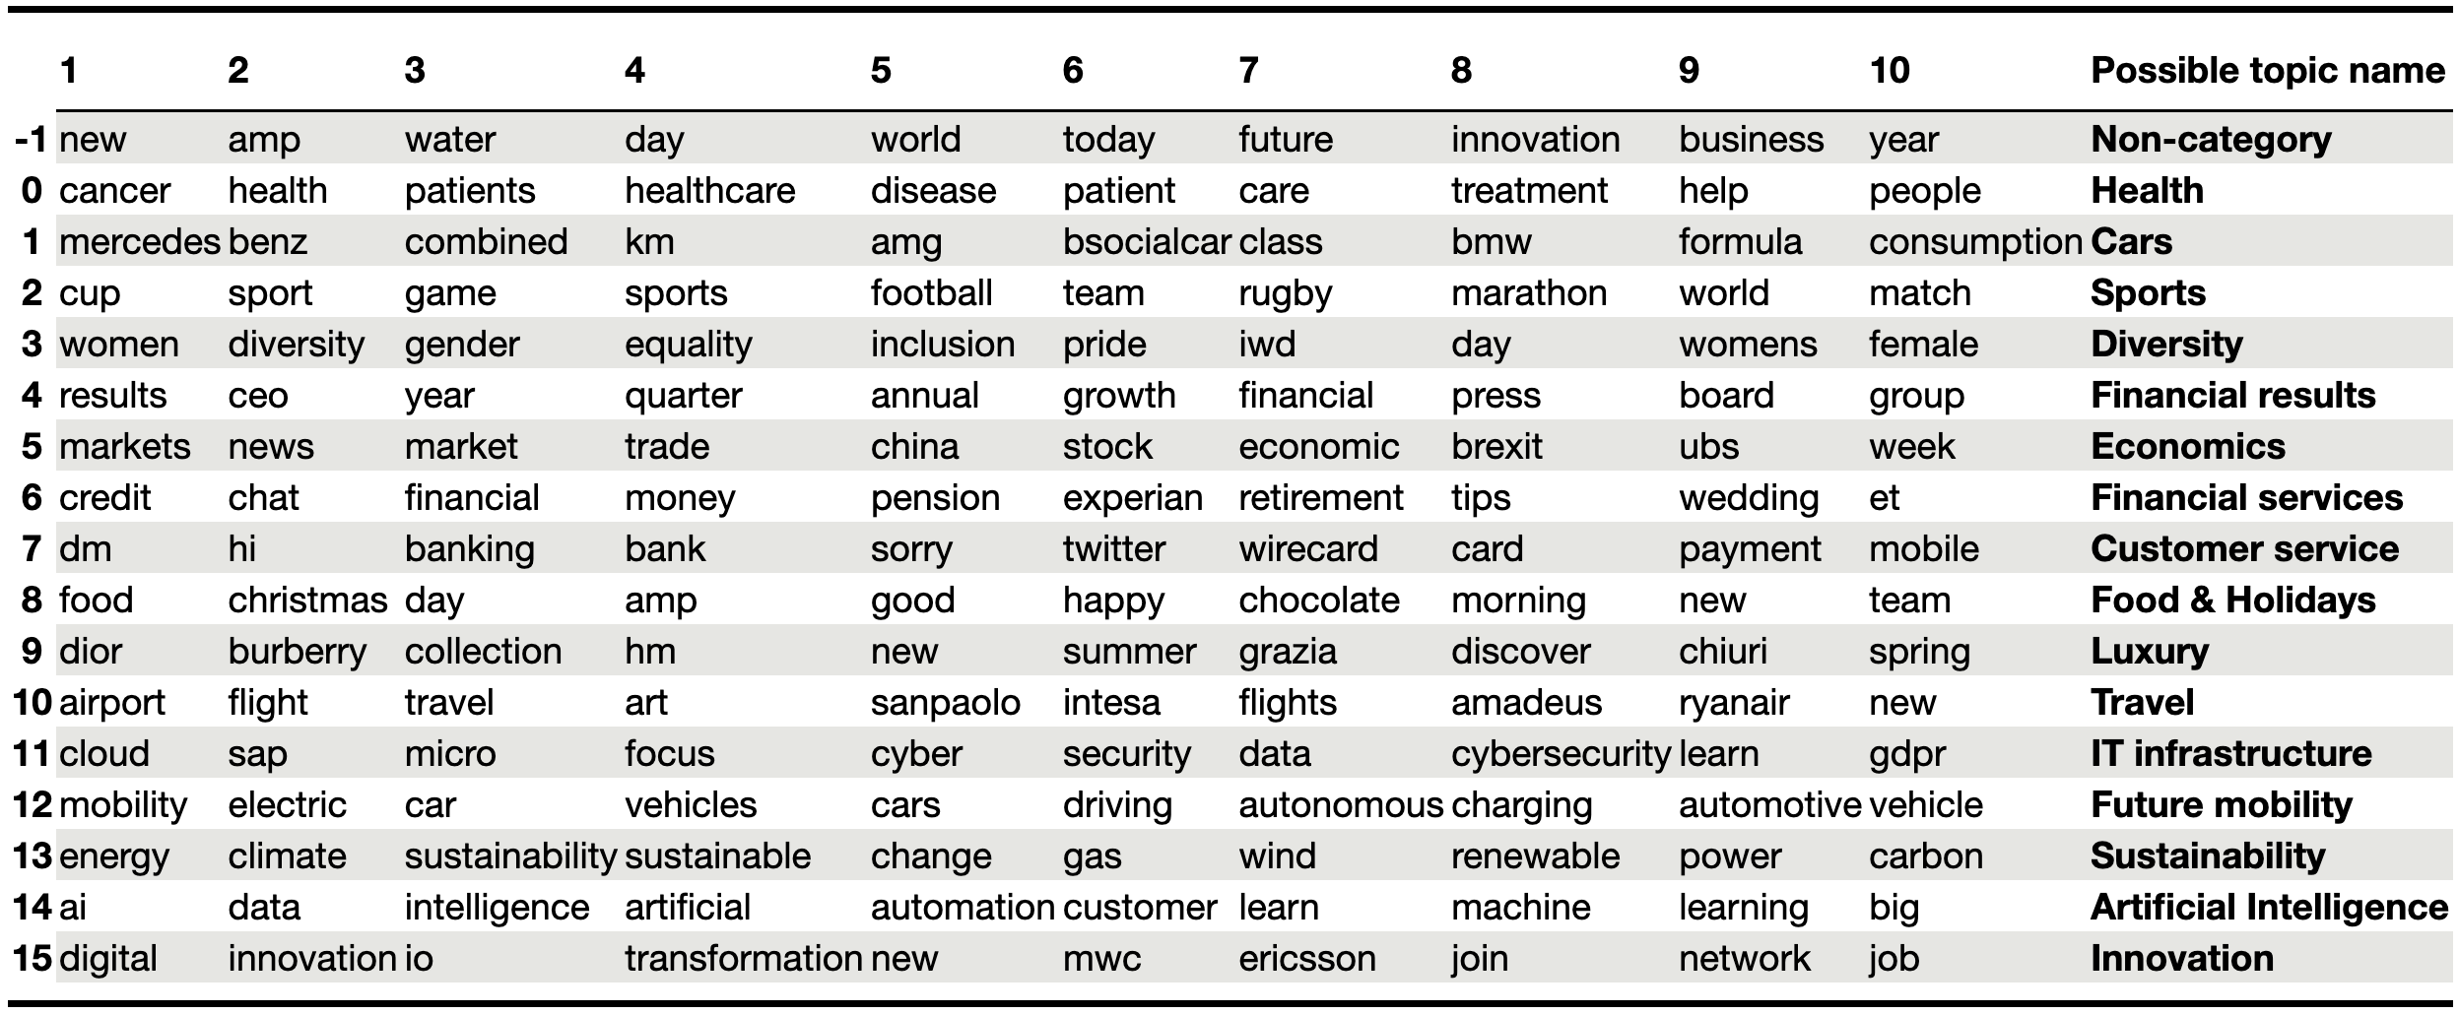

### Note on IT infrastructure and reproducibility

The embedding and clustering processes require more computational power and memory than most commercially available computers offer. Also, the more algorithms and functions, the more difficult it becomes to reproduce the approach. For example, the UMAP algorithm only works in conjunction with specific versions of its dependencies. This research conducted the analysis in a Docker container on a cloud server to overcome both problems, limited computational resources and reproducibility. The advantages of a cloud infrastructure are evident. The exact resources needed for a particular stage of the project are readily available at a reasonable cost. Docker, for its part, has several advantages. It provides separate environments, so-called containers, which are installed on a specific server but can contain a software stack of their own. Suppose a project requires a particular version of a programming language and packages in specific versions. All these can be installed in a container without having to adapt, duplicate or delete software on the server. A Dockerfile is a recipe that defines how and where to install software inside a container. Suppose a Dockerfile is in the project folder. In that case, a single command can trigger it to restore the development environment on any server, making it easy to switch servers and helping reproducibility. Any interested person can clone the project folder, deploy a container and reproduce the data analysis. This research provides the project folder and a Dockerfile in a public GitHub repository. The link is in the appendix.

# Results and discussion

## Overall protests and tweeting

This part is a descriptive analysis to understand how companies tweeted in the chosen period, how many people protested, and how these variables relate to each other. Figure 3 shows the relative proportion of tweets on sustainability of all companies surveyed. Greta Thunberg and a few supporters first protested in front of the Swedish Parliament in week 2018-34. In the weeks and months running up to this inflexion point, the rate of sustainability tweets mainly was between 5 and 6.5, with a median of approximately 5.5%. There are three noticeable peaks above 7 per cent in the pre-FFF period. Possible explanations for the high values could be relevant global events that prompted companies to communicate more on sustainability. The week 2017-50 saw the first One Planet Summit in Paris, Earthday took place during the week 2018-16 and the week 2018-23 saw the G7 hold its summit. From the week 2018-34 onwards, the median increases by approximately 0.8% and peaks become higher and more frequent. From spring 2019, the rate falls below five per cent only once.

Figure : Overall share of corporate tweets on the topic of sustainability

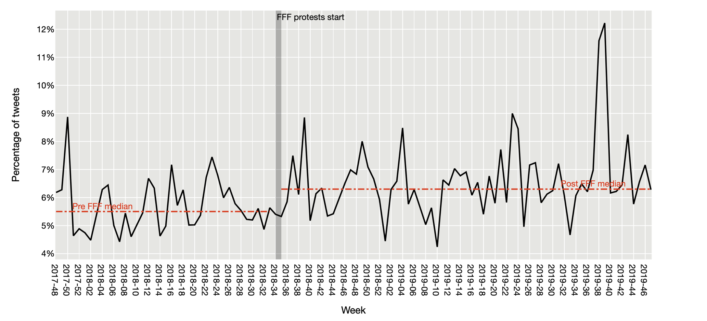

Figure 4 covers the same period as Figure 3, but the graph shows the total number of protesters in the selected European countries per week. It clearly shows the significant differences in the size of FFF protests. The most striking peaks are in September 2019, when the Global Week for Future took place from the 20th to the 27th. Some media called the events on September 20th, which kicked the week off, the biggest climate protest in history (Laville and Watts 2019) (Barclay and Resnick 2019). It mobilised almost 4,000,000 people in the selected European countries and over 6,000,000 worldwide. The ensuing Friday saw protests of almost equal size. The peaks in September 2019 coincide with the maximum rate of sustainability tweets in Figure 3. The simultaneous rapid increase in the tweets’ rate can plausibly be attributed to the size and associated attention of the FFF protests. Furthermore, protest size and the percentage of tweets have a high Pearson correlation coefficient of almost 0.6 with an associated p-value well below 0.01. Over time, protest size captures much variation in the share of tweets related to sustainability.

Figure : Protesters in selected European countries per week

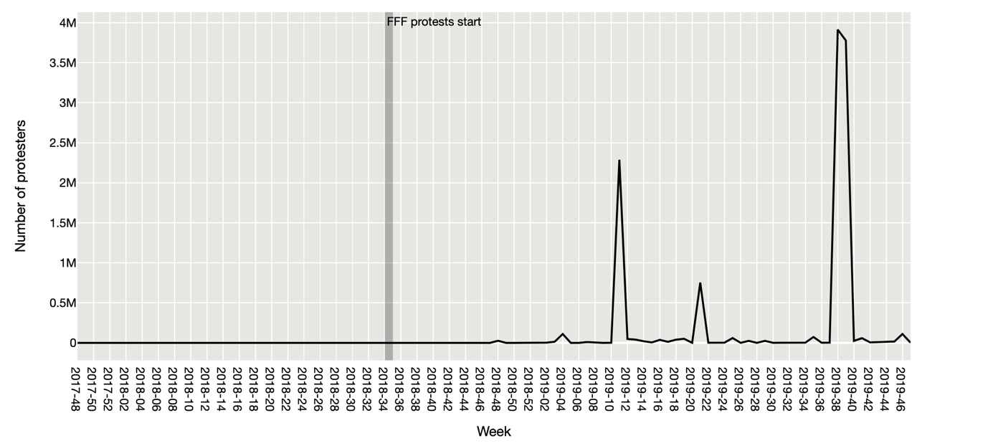

However, the other two peaks of the protest movement in weeks 2019-11 and 2019-21 did not trigger an analogous behaviour of the curve in Figure 3 which suggests that the influence of FFF protests has not been uniform and likely compounded over time. Hypothetically, a protest with a certain number of participants later in 2019 attracted disproportionately more attention than a protest of the same type and size that would have taken place earlier. This is because awareness and associated attention build up over time. In addition, numerous other internal and external factors influence companies’ communication on Twitter.

Overall, companies started tweeting more about sustainability in the wake of FFF. The remarkably high Pearson coefficient, the screening of both graphs, and the theoretical background support the hypothesis that a positive relationship exists. The precise coincidence in September 2019 suggests that protests most likely directly influenced corporate communication with a strong impulse in September 2019. They may have contributed indirectly to an atmosphere conducive to sustainability communication during the rest of the time. However, the non-coincidence of smaller protest peaks with peaks in sustainability tweets shows that protests were, ultimately, one factor among many. We should, thus, not overestimate them. Finally, it is important to mention that this research cannot prove whether protest size directly affected the communication activity of companies. The setup does not allow a causal analysis because the fundamental assumption of standard unit treatment value (SUTVA) is not fulfilled.

Hooghiemstra (2000) and Deegan (2019) describe companies’ legitimising and strategic disclosure reaction to adverse social events and public pressure. The data show that this reflex also applies to social movements under certain circumstances. The enormous reaction at the end of September 2019 can be described as a legitimisation offensive designed to stem the tide of public pressure.

## 2B or not 2B

In this part of the analysis, the aim is to find differences between B2B and B2C firms concerning their communication on Twitter and sensitivity to FFF protests. Two main arguments lead to hypotheses H2a and H2b. First, Twitter is generally less important for B2B firms, and second, B2C companies are more directly affected by social movements because protesters are also consumers. Therefore, B2C companies have a greater incentive to respond to social movements.

The data reveal that reality is more complex than theory. Figure 5 shows that B2B companies tweet significantly more on sustainability. The difference is surprising. Its magnitude is even more unexpected considering, for example, the topic of diversity, which is also a part of corporate responsibility but much more balanced. Topics related to research and development, like Artificial Intelligence or Innovation, are also more evenly distributed. What is in line with expectations, on the other hand, is the fact that B2C companies tweet more across all topics. However, the difference is negligible.

Figure : Number of tweets per Topic per Context before and after FFF protests

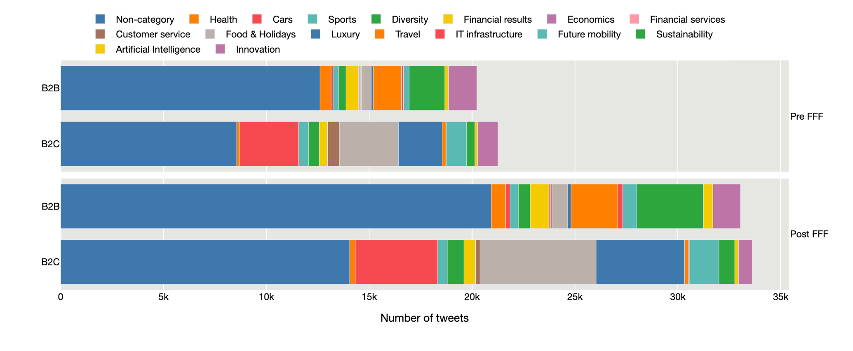

The relative figures over time show a similar picture. Indeed, the share of sustainability tweets by B2B companies is higher every week. Moreover, the median is higher for the B2B group after the FFF protests, while it remains constant for B2C firms. There is a clear peak in the week of the largest FFF protests for both groups, highlighting overall findings in 9.1. Both curves become more volatile with the start of the protests, which could indicate that external factors became more influential.

Figure 6: B2B and B2C companies’ overall shares of sustainability tweets per week

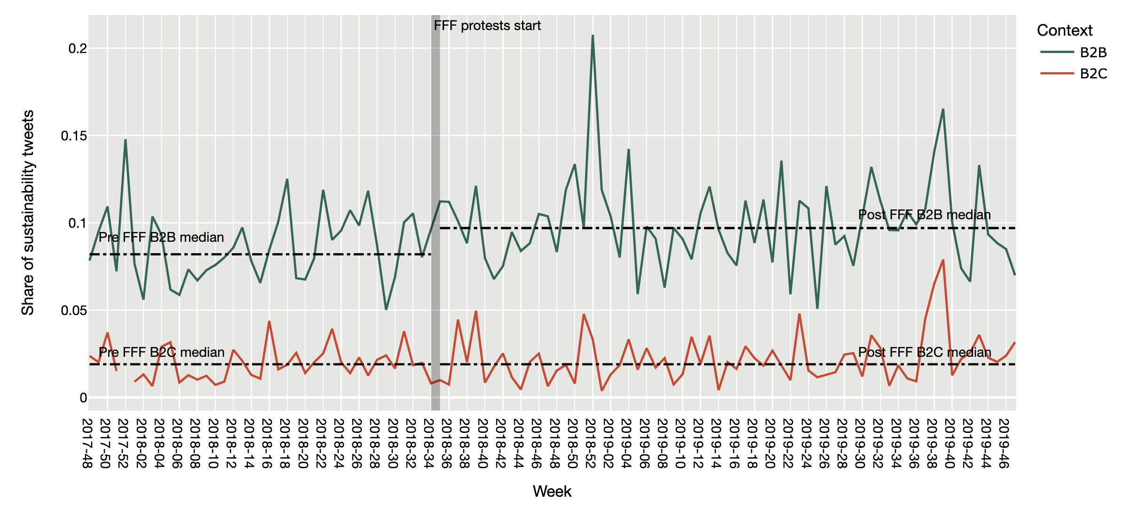

However, a closer, critical look at the variables in Table 4 puts Figures 5 and 6 into perspective. Outliers and methodological caveats could explain the difference between the two groups. There are companies in the B2B group whose tweets are on sustainability in 80% of cases. The company with the highest ratio is called Acciona, a Spanish conglomerate that specialises in renewable energies. Of course, companies who produce sustainable solutions communicate almost exclusively on this topic, just as a vehicle manufacturer would tweet about cars most of the time. Acciona and similar companies account for a lot of the B2B group’s sustainability tweets in absolute terms and drive up the weekly rate in Figure 6. However, the higher median and quartiles show that B2B companies tend to tweet more about sustainability in absolute and relative terms even if outliers are disregarded. Therefore, figures 5 and 6 reflect the correct tendency but might overestimate the difference between the groups.

Table : B2B and B2C companies’ tweets related to sustainability

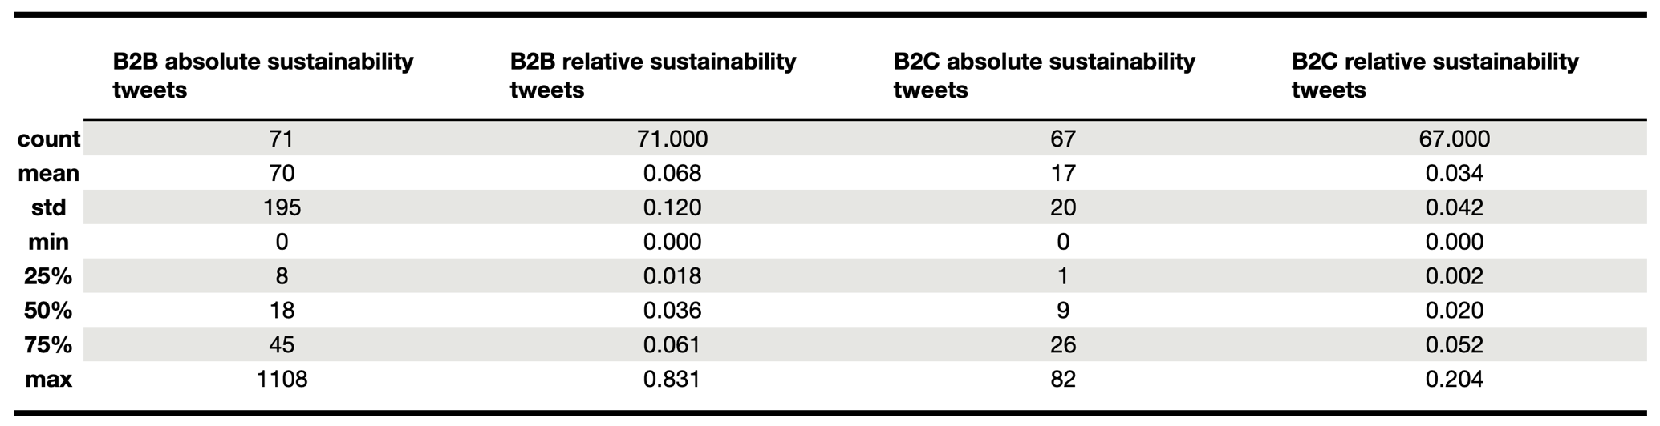

Another noticeable number in Table 4 is the minimum zero value for both groups. According to the table, a quarter of B2C companies never or rarely tweet on sustainability. A manual inspection of these companies found several reasons for this. First, some companies genuinely do not address corporate responsibility issues on Twitter. Some use the platform almost exclusively for advertising and customer service purposes. This research read through all the tweets of the German fashion retailer Zalando and found that they tweeted exclusively about new products and special offers. However, Zalando maintains another channel on Twitter aimed at media professionals that addresses corporate topics like sustainability. Other companies probably do the same. Maybe B2C companies apply this dichotomy more than B2B companies. The next reason concerns the clustering algorithm. Generally, it does not force a tweet into a category. However, manual inspection showed that the algorithm assigns a text to a category when it contains some of the most frequent keywords of one topic, even if it contains one or two lesser keywords of another topic. For example, consider a tweet that praises various features of a car, one of which is its efficiency. The algorithm tends to classify such a tweet into the “Cars” category because “Cars” is the dominant topic. The name of a car manufacturer, if it appears in a tweet, could be a decisive keyword to determine the dominant topic because it is strongly associated with it. For example, tweets containing the word “Mercedes” are mostly attributed to “Cars” because “Mercedes” is very specific. This company-name bias applies to all tweets equally, so it does not necessarily distort the B2B vs B2C analysis, but it is an opportunity for improvement in future research.

The three reasons behind the minimum value of zero, on the one hand, show methodological issues and, on the other hand, illustrate a more general problem. Topic classifications are fundamentally subjective. While there are certain clear-cut cases, short texts are often particularly ambivalent. Reading out a defining topic or a common thread from a few sentences can be difficult. Presumably, human coders would also reach different conclusions in borderline cases.

Figure 6 shows that B2B companies increased the share of sustainability tweets over time, which could mean that they are more sensitive to FFF protests. However, this does not have to be the case. Maybe other factors explain the increase. This research conducted standardised linear regressions for B2B and B2C companies to address hypothesis H2b. Standardised linear coefficients, sometimes called sensitivity coefficients, can capture the linear influence of an input variable on a response (Zagayevskiy and Deutsch 2011). In this case, the standardised linear regression coefficient indicates how many standard deviations the share of sustainability tweets increases in a week if the protest size increases by exactly one standard deviation in the same week. Using the standardised instead of the original values also improves the interpretability of the results. Otherwise, the coefficient would have indicated the per cent increase in sustainability tweets per additional single protester, which is a somewhat elusive figure.

For B2B companies a significant regression equation was found (F(1, 64) = 7.288, p < 0.009), with an R2 of 0.102. The predicted share of sustainability tweets equals 0 + 0.320 * (PROTESTERS), where the independent variable is standardised and, thus, measured in standard deviations. For B2C companies the same applies with (F(1, 64) = 36.89, p < 0.000), an R2 of 0.366 and 0 + 0.605 * (PROTESTERS). The predictors are significant in both groups. The B2C group model predicts that one standard deviation of additional protesters, which corresponds to about 700,000 people, will result in 0.605 standard deviations of relative sustainability tweets, which corresponds to a 2.5% (0.605 * 0.042 = 0.025) increase. From the fact that the coefficient of the B2C group is almost twice as large and the R2 is more than three times the size, we can deduce that the relative share of sustainability tweets of this group is more sensitive to the size of FFF protests.

In conclusion, hypothesis H2a can be rejected, and hypothesis H2b is accepted. The data have shown that B2B companies do not neglect Twitter. The idea of Swani et al. (2014) and Iankova et al. (2019) that social media is a B2C domain is outdated. B2B firms are active and even tweet more about sustainability which echoes Rudawska’s (2019) findings. Also, they increased coverage of climate-related matters over the period studied. However, they are less sensitive to FFF than their B2C homologues, in the sense that the size of FFF protests does not explain as much variation in their share of sustainability tweets as it does in the B2C group. Other factors favouring sustainability communication may play a more prominent role for B2B firms than social movements. In principle, however, there are reservations. We should remember that individual companies in the B2B group distort the overall picture. Plus, methodological caveats question whether the approach, in general, depicts the complete Twitter activity.

## Nations, Transnational FFF and multinational companies

In this part of the paper, the companies are grouped into their countries of origin. Hypothesis H3 predicts that companies in France and Sweden will often tweet about sustainability and respond strongly to social movements such as FFF. For the analysis, only countries with more than 25 companies represented in the Forbes 2000 list were selected to ensure sufficiently large groups. However, the groups still vary in size. The UK has 82, France 57, Germany 53, Switzerland 41, Italy 27 and Sweden 26 members.

Figure : Shares of sustainability tweets in European countries with more than 25 companies on the Forbes list

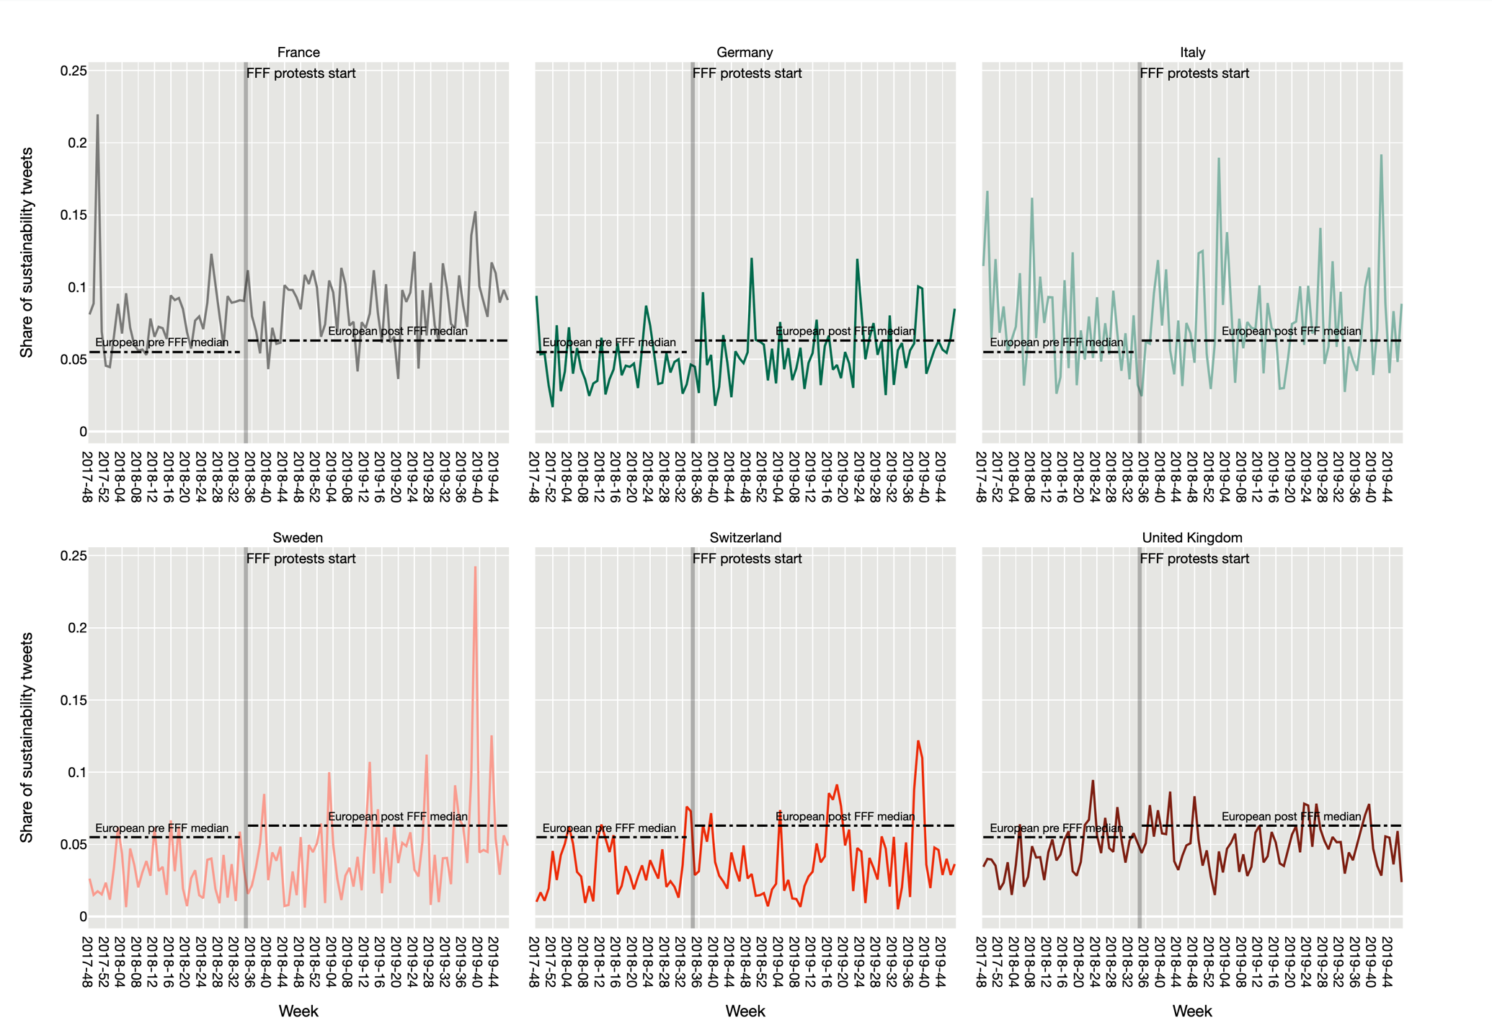

Figure 7 shows the curves for the six countries, the start of FFF protests and the European medians. As expected, French companies tweet more than average on sustainability. However, the highest peak occurred before the FFF protests, in the week of 2017-50, when the One Planet Summit took place in Paris, a multi-stakeholder gathering initiated by French politics and business. Germany is about half a percentage point below France, but a slight upward trend can be seen over time. The peaks during the Global Week for Future in September 2019 are surprisingly low. The Italian curve is also above average, but its extraordinary volatility stands out. It is unclear what caused this and the high peak in 2019-02. Sweden has a low percentage of sustainability tweets, but the upward trend is very pronounced. The trend and the clear peaks after the start of the FFF protests indicate that Swedish companies could be sensitive to the movement. A sensitivity analysis will have to clarify whether this is indeed the case. Switzerland’s curve is comparable to Sweden’s before FFF. Then it remains relatively constant and below the European level. However, its peaks are pronounced and aligned with the European picture in Figure 3. The British curve is slightly below the European median and shows a slight downward trend at the end of the period, which makes it a clear exception.

To understand how companies in a given country align sustainability communication with protests from FFF, a similar sensitivity analysis as in 9.2 is appropriate. The independent variable for each country is the standardised number of protesters in Europe, and the dependent variable is the standardised proportion of sustainability tweets per country. Table 5 gives an overview of all six regressions. As expected from the screening of the graphs, the independent variable explains most of the variance for firms in Sweden. One standard deviation of protesters, which corresponds to about 700,000 people, results in a 0.523 standard deviation higher percentage of tweets on sustainability, which corresponds to a 1.5% increase in the Swedish case. Sweden’s companies are, therefore, most sensitive to FFF protest size. Switzerland is close second and France third. The only non-significant coefficient is Italy’s. Therefore, the volatility of its curve is due to other unknown factors.

Table : Regressions of sustainability share on protest size per country

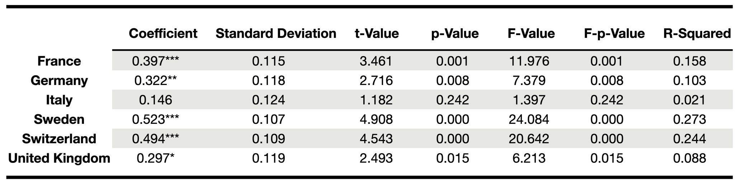

Overall, Figure 7 and Table 5 give similar pictures. France is first in relative sustainability tweets, while Sweden is the most sensitive country to FFF protest size. The United Kingdom is last in the first comparison and penultimate in the second. Thus, it confirms that companies in classic LMEs are relatively reticent about non-market issues. However, sustainability is not necessarily less important in LMEs. As LME companies interact with a more restrained set of actors, they may shift their sustainability communication to more specialised channels other than Twitter. Reports, for example, reach a smaller but more specific audience that may be more relevant in LMEs. Perhaps LME companies simply use Twitter more as a marketing and less as a PR platform.

According to Hofstede’s data in Soerensson et al. (2019), what links France and Sweden is that both are individualistic countries. If this factor is decisive, it could mean that the value of personal development is linked to the pursuit of legitimacy by firms. In the absence of groups and families in the broader sense, people in individualistic societies might align themselves more with an abstract overarching value system. The act of consumption could be a form of self-expression, where the values a product stands for are at least as important as its direct utility. Companies may, therefore, feel pressure to give their products the values that consumers are looking for, which makes them reach a state of congruence with the social system. These considerations could lead to the hypothesis that firms in individualistic CMEs strive for legitimacy more than their LME counterparts.

# Conclusion

This research explored the link between FFF protests and corporate communication behaviour on Twitter. The tweets of large European companies over two years were classified into topics with a deep bidirectional natural language processing algorithm, dimensionality reduction and clustering. The method is relatively new and has several advantages over more traditional approaches, including synonym recognition, a non-predetermined number of clusters, context awareness and automatic identification of other topics. The goal was to find correlations between FFF protest size and the share of corporate tweets related to sustainability.

Corporate sustainability tweets increased in relative terms after FFF protests started. There is a clear maximum during the Global Week for Future in September 2019. However, other peaks in protest size did not coincide with increases in the share of tweets, which suggests that FFF’s power compounded over time and climaxed in autumn 2019. Another critical finding challenges studies assuming that B2C companies are more active on Twitter to cultivate their reputation. This research has shown that this idea is outdated. B2B companies tweet only marginally less, and they even communicate significantly more on sustainability. B2C companies, on the other hand, are more sensitive to the size of FFF protests which suggests that their communication agenda is more directly affected by social movements. The third key finding concerns national differences in sustainability communication in the wake of FFF. French companies tweet more than average on sustainability compared to other countries and rank third in sensitivity to FFF protests. Sweden ranks first in terms of sensitivity, but its companies tweeted less than average on climate-related matters. Both countries show a clear upward trend over time and stand out overall, which was predicted by H3 and is consistent with the theoretical projection.

Studies on differences in communication between B2B and B2C companies are relatively rare. The existing theory would need to be updated to consider social media penetration along the entire value chain. Companies that do not directly supply consumers and whose brands are less well-known use Twitter intensively too. However, they set their communication agenda differently and target other stakeholders than civil society. Another theoretical implication concerns the national character, which reflects in companies’ communication behaviour. Although most are globally active and have an international workforce, there are remarkable differences. Communication theories should not underestimate the national economic and cultural contexts.

The findings are encouraging for FFF. The movement was able to take an agenda-setting position. It directly influenced corporate communication across Europe and contributed to a general atmosphere conducive to sustainability communication. However, the sensitivity of the companies differs according to country and context. Protests are most effective in countries like France and Sweden, at least in terms of the response from the business community. Companies and communication specialists could use this research to help identify how context and country shape behaviour on Twitter. They could retrospectively analyse content and compare it with other companies or times, which can help implement a strategy or identify blind spots. Consumers and individuals can better understand how a protest on the street can affect messages from companies. Suppose in the wake of a social movement it seems that all companies are suddenly green because they are promoting products and corresponding aspirations. This can be an over-compensating reaction rather than a reflection of reality.

The most important contribution of this research is methodological. It used a relatively new computational method to address a concrete social sciences problem. This research has shown that individuals can analyse large amounts of data without owning the necessary hardware, with modest financial resources, without having a computer science background and by investing a reasonable amount of time. An improvement for reproducibility is also suggested. Docker should be used in more studies so that anyone can effortlessly recreate the development environment. Reproducing studies is often tricky because parts of code stop working with time due to updated dependencies or deprecated functions. Docker and Dockerfiles solve this issue.

Stanik, Pietz and Maalej (2021) have shown that their method achieves better results than traditional approaches. However, this research found an important caveat regarding the treatment of ambivalent short texts. In some cases, texts are assigned to one category, although they also contain keywords of another category. Manual inspection has shown that the presence of particularly important words might decide which topic dominates. Sometimes company names are among these critical words. Future research should systematically exclude the subject’s names from texts to avoid this bias. A second limitation concerns the choice of Twitter channels. Some firms have multiple channels on Twitter, which means that this research did not fully capture every company’s presence on the platform. Future studies should take this into account.

Finally, the Twitter data and associated topics are publicly available, hoping that future studies will draw more insights. This research focused on sustainability and largely ignored other topics the algorithm found. However, the same data could be used to create comprehensive Twitter communication profiles and thus show the companies’ activity more holistically. Correlations of other external factors could be included to explain phenomena with topics such as diversity, AI or innovation. Also, the groups of firms formed in this research, namely countries and B2B/B2C, are only two possibilities among many. One could ask the same questions about FFF in relation to different industries, economic sectors, or the firms’ sizes.

# Bibliography

Aldrich, Howard E, and C Marlene Fiol. 1994. ‘Fools Rush in? The Institutional Context of Industry Creation’. *Academy of management review* 19(4): 645–70.

Alrazi, Bakhtiar, Charl de Villiers, and Chris J. van Staden. 2015. ‘A Comprehensive Literature Review on, and the Construction of a Framework for, Environmental Legitimacy, Accountability and Proactivity’. *Journal of Cleaner Production* 102: 44–57.

Araujo, Theo, and Jana Kollat. 2018. ‘Communicating Effectively about CSR on Twitter: The Power of Engaging Strategies and Storytelling Elements’. *Internet Research*.

Barclay, Eliza, and Brian Resnick. 2019. ‘How Big Was the Global Climate Strike? 4 Million People, Activists Estimate.’ https://www.vox.com/energy-and-environment/2019/9/20/20876143/climate-strike-2019-september-20-crowd-estimate (March 17, 2022).

Barnes, Nora Ganim, Ashley Mazzola, and Mae Killeen. 2020. ‘Oversaturation & Disengagement: The 2019 Fortune 500 Social Media Dance - The Effects of High Level Social Media Interactions across Media Platforms.’ https://www.umassd.edu/cmr/research/2019-fortune-500.html.

Bergek, Anna, Staffan Jacobsson, and Björn A. Sandén. 2008. ‘“Legitimation” and “Development of Positive Externalities”: Two Key Processes in the Formation Phase of Technological Innovation Systems’. *Technology Analysis & Strategic Management* 20(5): 575–92.

Berrone, Pascual, Andrea Fosfuri, and Liliana Gelabert. 2017. ‘Does Greenwashing Pay Off? Understanding the Relationship Between Environmental Actions and Environmental Legitimacy’. *Journal of Business Ethics* 144(2): 363–79.

Berrone, Pascual, Liliana Gelabert, and Andrea Fosfuri. 2009. ‘The Impact of Symbolic and Substantive Actions on Environmental Legitimacy’. *IESE Business School*.

Brennan, Ross. 2014. ‘The End of Corporate Social Responsibility: Crisis & Critique, by Peter Fleming and Marc t. Jones’.

Brown, Noel, and Craig Deegan. 1998. ‘The Public Disclosure of Environmental Performance Information—a Dual Test of Media Agenda Setting Theory and Legitimacy Theory’. *Accounting and business research* 29(1): 21–41.

dataworld. 2021. ‘Data.World Forbes Global 2000 - 2019’. https://data.world/aroissues/forbes-global-2000-2008-2019/workspace/file?filename=Forbes+Global+2000+-+2019.csv.

Deegan, Craig Michael. 2019. ‘Legitimacy Theory: Despite Its Enduring Popularity and Contribution, Time Is Right for a Necessary Makeover’. *Accounting, Auditing & Accountability Journal*.

Deegan, Craig, and Michaela Rankin. 1996. ‘Do Australian Companies Report Environmental News Objectively? An Analysis of Environmental Disclosures by Firms Prosecuted Successfully by the Environmental Protection Authority’. *Accounting, auditing & accountability journal*.

Fleming, Peter. 2012. *The End of Corporate Social Responsibility*. SAGE. https://books.google.ch/books?id=w89sDWnDDWkC&dq=The+End+of+Corporate+Social+Responsibility.&lr=&source=gbs_navlinks_s.

Fridays for Future. 2021. ‘List of Countries’. https://fridaysforfuture.org/what-we-do/strike-statistics/list-of-countries/.

———. 2022. ‘Our Demands’. *Fridays for Future*. https://fridaysforfuture.org/what-we-do/our-demands/ (March 30, 2022).

Hall, Peter A, and David Soskice. 2001. ‘An Introduction to Varieties of Capitalism’. *op. cit*: 21–27.

Hassan, Abeer, and Xin Guo. 2017. ‘The Relationships between Reporting Format, Environmental Disclosure and Environmental Performance. An Empirical Study’. *JOURNAL OF APPLIED ACCOUNTING RESEARCH* 18(4): 425–44.

Hofstede, Geert. 2011. ‘Dimensionalizing Cultures: The Hofstede Model in Context’. *Online readings in psychology and culture* 2(1): 2307–0919.

Hooghiemstra, Reggy. 2000. ‘Corporate Communication and Impression Management – New Perspectives Why Companies Engage in Corporate Social Reporting’. *Journal of Business Ethics* 27(1): 55–68.

Iankova, Severina et al. 2019. ‘A Comparison of Social Media Marketing between B2B, B2C and Mixed Business Models’. *Industrial Marketing Management* 81: 169–79.

Kwak, Jooyoung, Yue Zhang, and Jiang Yu. 2019. ‘Legitimacy Building and E-Commerce Platform Development in China: The Experience of Alibaba’. *Technological Forecasting and Social Change* 139: 115–24.

Laville, Sandra, and Jonathan Watts. 2019. ‘Across the Globe, Millions Join Biggest Climate Protest Ever’. *The Guardian*. https://www.theguardian.com/environment/2019/sep/21/across-the-globe-millions-join-biggest-climate-protest-ever (March 17, 2022).

Marquardt, Jens. 2020. ‘Fridays for Future’s Disruptive Potential: An Inconvenient Youth Between Moderate and Radical Ideas’. *frontiers in Communication*. https://www.frontiersin.org/articles/10.3389/fcomm.2020.00048/full.

Maurer, John G. 1971. *Readings in Organization Theory: Open-System Approaches*. Random House (NY).

McInnes, Leland. 2018. ‘UMAP: Uniform Manifold Approximation and Projection for Dimension Reduction’. *UMAP*. https://umap-learn.readthedocs.io/en/latest/ (December 1, 2021).

Merle, Marie, Gerhard Reese, and Stefan Drews. 2019. ‘#Globalcitizen: An Explorative Twitter Analysis of Global Identity and Sustainability Communication’. *Sustainability* 11(12). https://www.mdpi.com/2071-1050/11/12/3472.

Mousa, Gehan, and Naser T Hassan. 2015. ‘Legitimacy Theory and Environmental Practices: Short Notes’. *International Journal of Business and Statistical Analysis* 2(01).

Murphy, Andrea. 2015. ‘2015 Global 2000: Methodology’. *forbes.com*. https://www.forbes.com/sites/andreamurphy/2015/05/06/2015-global-2000-methodology/?sh=72ddf97d70f9.

Nath, Atanu, Parmita Saha, and Esmail Salehi-Sangari. 2019. ‘Blurring the Borders between B2B and B2C: A Model of Antecedents behind Usage of Social Media for Travel Planning’. *Journal of business & industrial marketing*.

Nwagbara, Uzoechi, and Patrick Reid. 2013. ‘Corporate Social Responsibility Communication in the Age of New Media: Towards the Logic of Sustainability Communication’. *Review of International Comparative Management* 14(3). https://www.ceeol.com/search/viewpdf?id=746635.

Oliver, Christine. 1991. ‘STRATEGIC RESPONSES TO INSTITUTIONAL PROCESSES’. *Academy of Management Review* 16(1): 145–79.

Prado-Roman, Camilo, Francisco Diez-Martin, and Alicia Blanco-Gonzalez. 2020. ‘The Effect of Communication on the Legitimacy and Performance of Organizations’. *Revista Brasileira de Gestão de Negócios*.

Rudawska, Edyta. 2019. ‘Sustainable Marketing Strategy in Food and Drink Industry: A Comparative Analysis of B2B and B2C SMEs Operating in Europe’. *Journal of Business & Industrial Marketing*.

Schenten, Ann Kristin. 2019. ‘Werbung for Future’. *Die ZEIT online*. https://www.zeit.de/gesellschaft/2019-09/greenwashing-fridays-for-future-werbung-unternehmen-aktivismus?utm_referrer=https%3A%2F%2Fwww.google.com%2F.

‘Sentence-Transformers/All-Mpnet-Base-V2’. *Hugging Face*. https://huggingface.co/sentence-transformers/all-mpnet-base-v2 (December 1, 2021).

‘Sentence-Transformers/Bert-Base-Nli-Mean-Tokens’. *Hugging Face*. https://huggingface.co/sentence-transformers/bert-base-nli-mean-tokens (December 1, 2021).

Silva, Samanthi. 2021. ‘Corporate Contributions to the Sustainable Development Goals: An Empirical Analysis Informed by Legitimacy Theory’. *Journal of Cleaner Production* 292: 125962.

Sörensson, Anna, Maria Bogren, and Annika Cawthorn. 2019. ‘Sustainability Information in Large-Sized Companies in Europe: Does National Culture Matter?’ *The International Journal of Sustainability in Economic, Social and Cultural Context* 15(1): 45–62.

Stanik, Christoph, Tim Pietz, and Walid Maalej. 2021. ‘Unsupervised Topic Discovery in User Comments’. In *2021 IEEE 29th International Requirements Engineering Conference (RE)*, , 150–61.

Stieglitz, Stefan, and Nina Krüger. 2011. ‘Analysis of Sentiments in Corporate TwitterCommunication – A Case Study on an Issue OfToyota’. *Association for Information Systems*. https://aisel.aisnet.org/cgi/viewcontent.cgi?article=1028&context=acis2011.

Swani, Kunal, Brian P Brown, and George R Milne. 2014. ‘Should Tweets Differ for B2B and B2C? An Analysis of Fortune 500 Companies’ Twitter Communications’. *Industrial marketing management* 43(5): 873–81.

United Nations. 2022. ‘The Paris Agreement’. *United Nations Climate Action*. https://www.un.org/en/climatechange/paris-agreement (March 30, 2022).

University of Helsinki. 2021. ‘Language Technology Research Group at the University of Helsinki’. *HuggingFace*. https://huggingface.co/Helsinki-NLP.

Vachon, Stephan. 2010. ‘International Operations and Sustainable Development: Should National Culture Matter?’ *Sustainable Development* 18(6): 350–61.

Vasylieva, Tetiana Anatoliivna, Serhii Viacheslavovych Lieonov, Inna Oleksandrivna Makarenko, and Natalie Sirkovska. 2017. ‘Sustainability Information Disclosure as an Instrument of Marketing Communication with Stakeholders: Markets, Social and Economic Aspects’.

Wahlström, Mattias et al. 2019. ‘Protest for a Future: Composition, Mobilization and Motives of the Participants in Fridays For Future Climate Protests on 15 March, 2019 in 13 European Cities’.

Walden, Darrell, and Bill N Schwartz. 1997. ‘Environmental Disclosures and Public Policy Pressure’. *Journal of accounting and Public Policy* 16(2): 125–54.

Weller, Katrin et al. 2014. ‘Twitter and Society: An Introduction’. *Twitter and society [Digital Formations, Volume 89]*: xxix–xxxviii.

Zagayevskiy, Yevgeniy V, and Clayton V Deutsch. 2011. ‘Updated Code for Sensitivity Analysis Based on Regression’. *Centre for Computational Geostatistics Annual Report* 13.

Zhang, Jing, and Mingfei Du. 2020. ‘Utilization and Effectiveness of Social Media Message Strategy: How B2B Brands Differ from B2C Brands’. *Journal of Business & Industrial Marketing*.

##### **Appendix A: Forbes Global 2000**

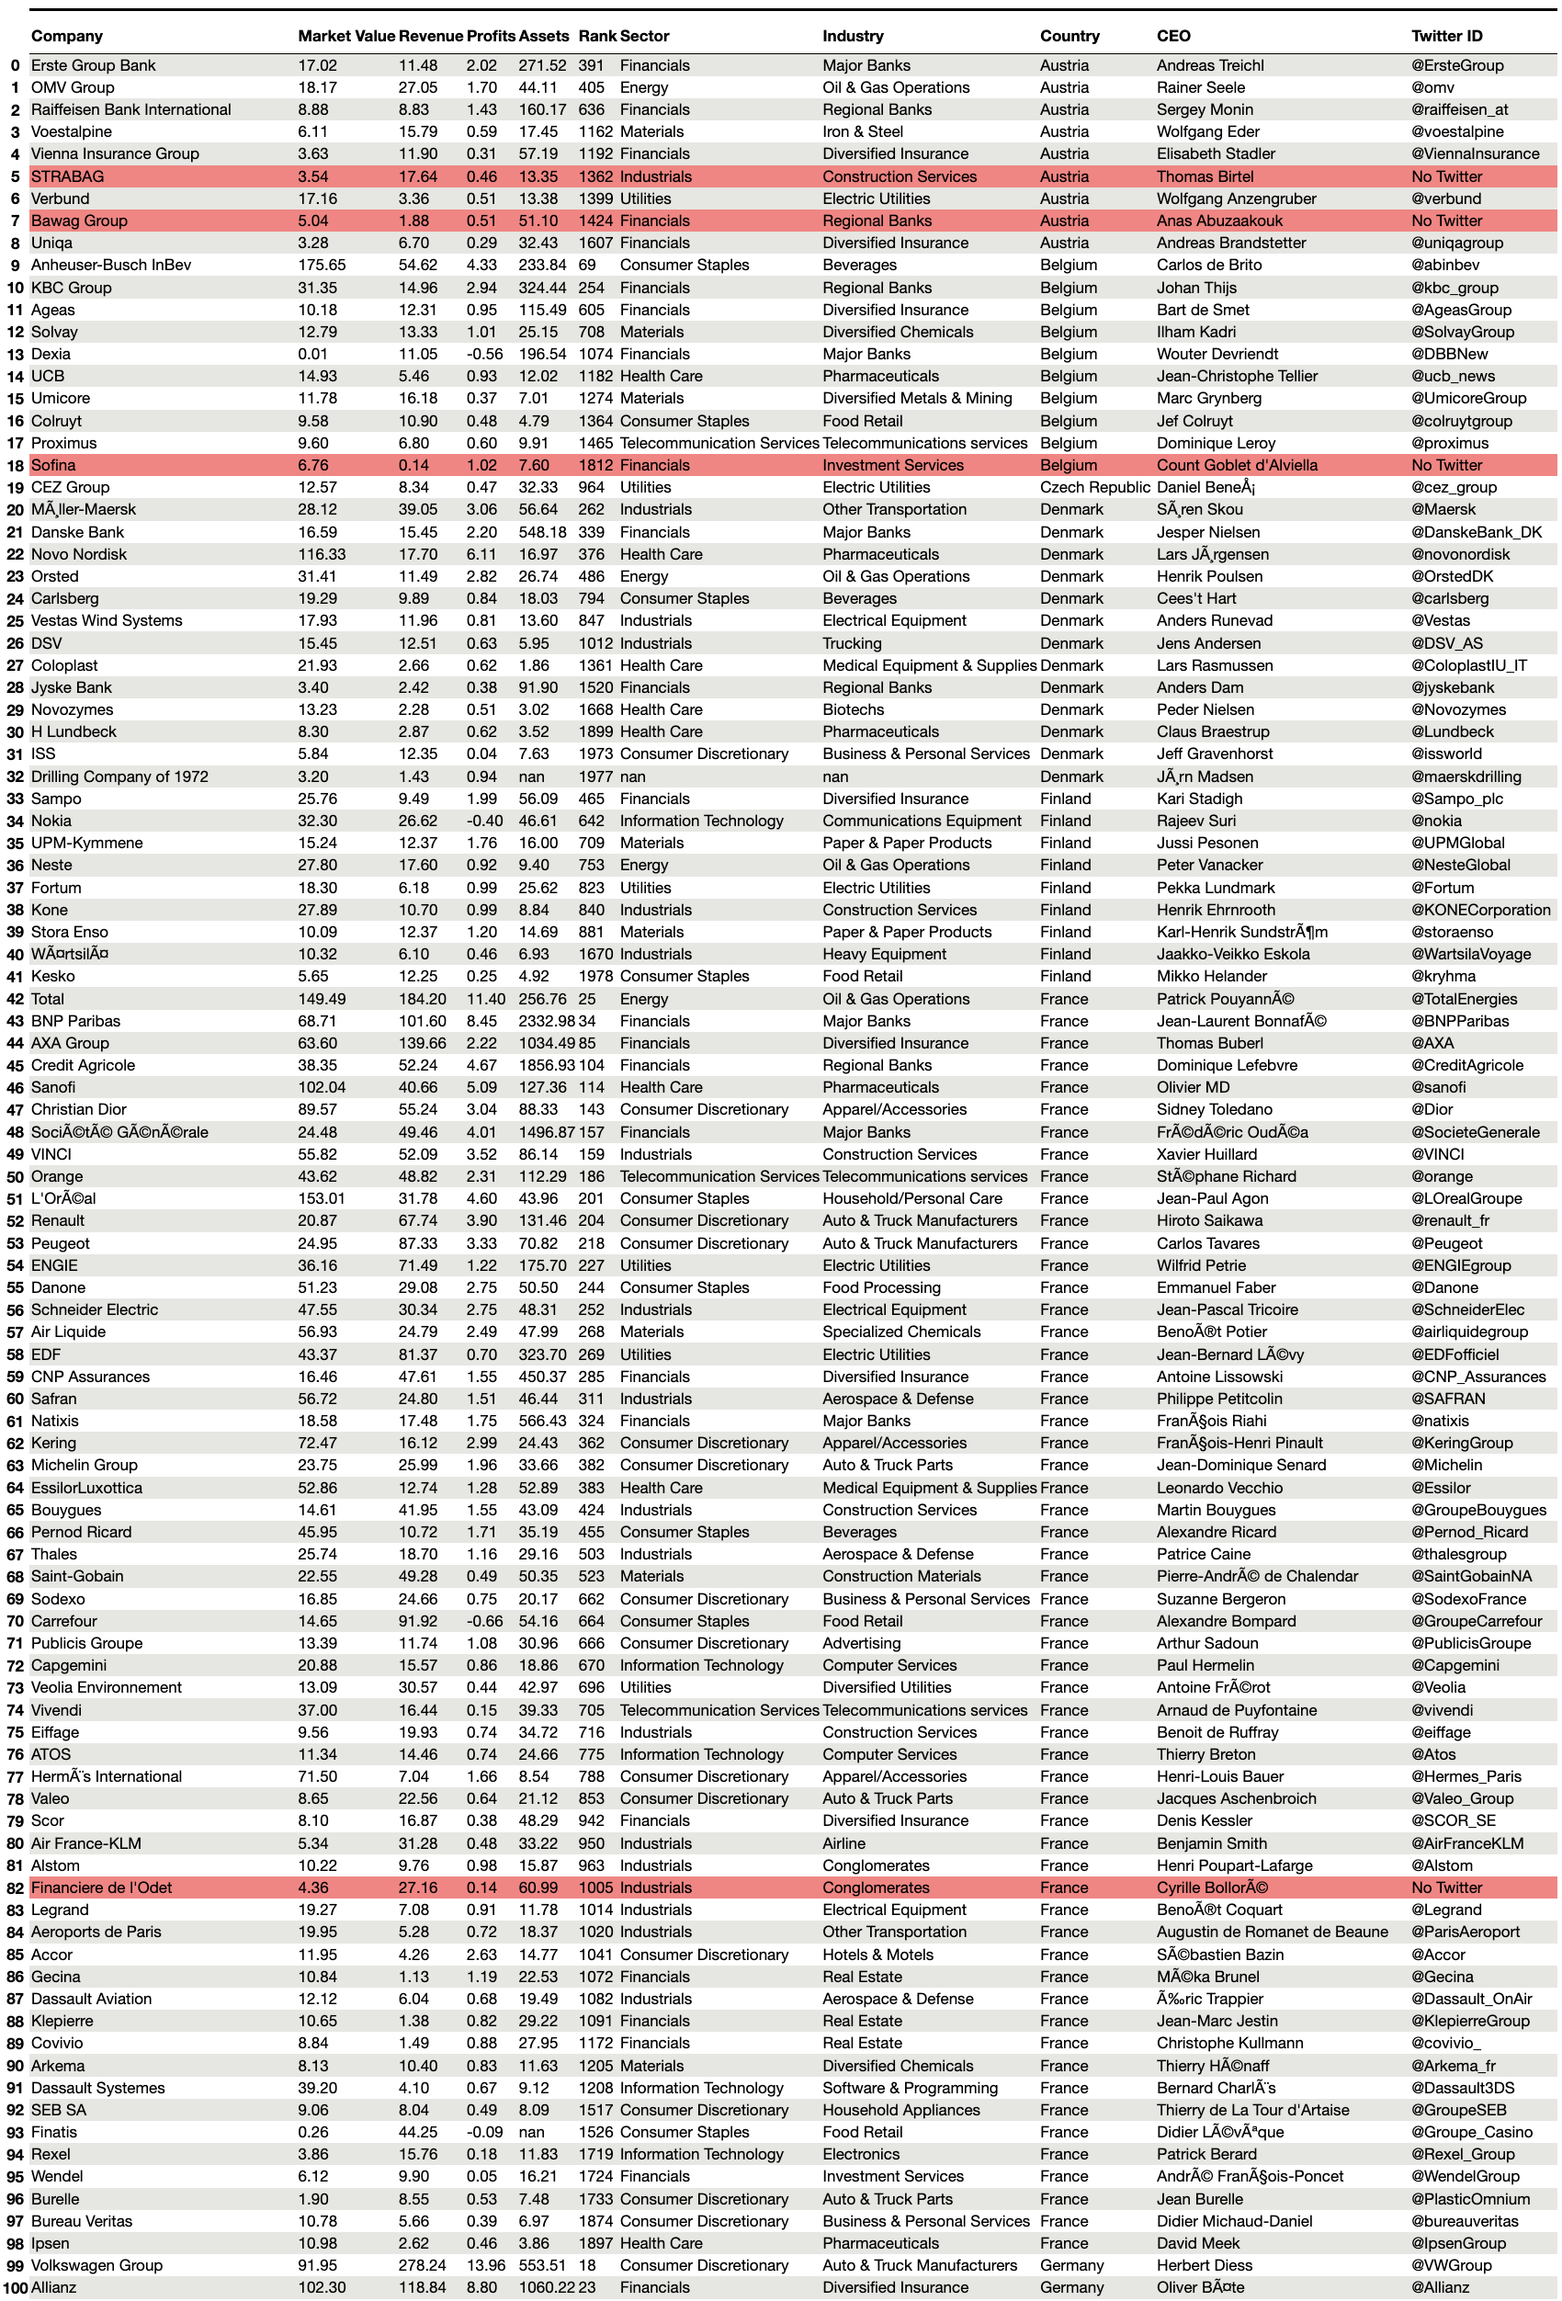

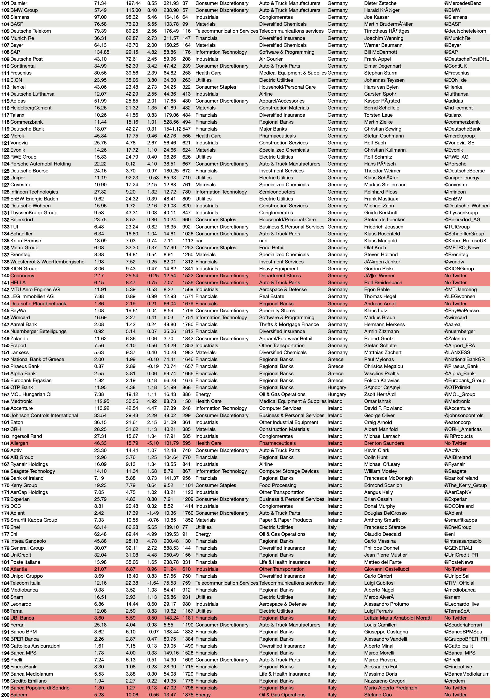

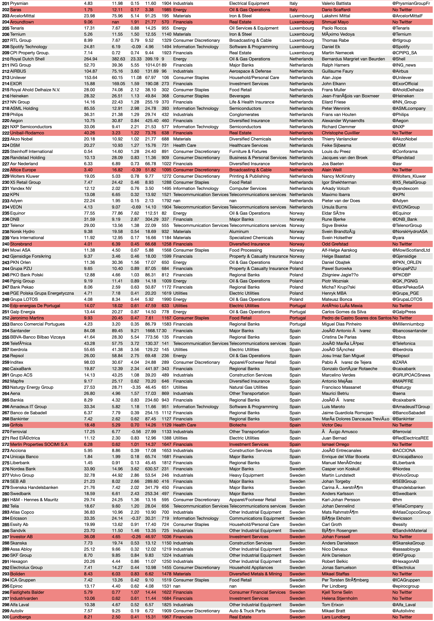

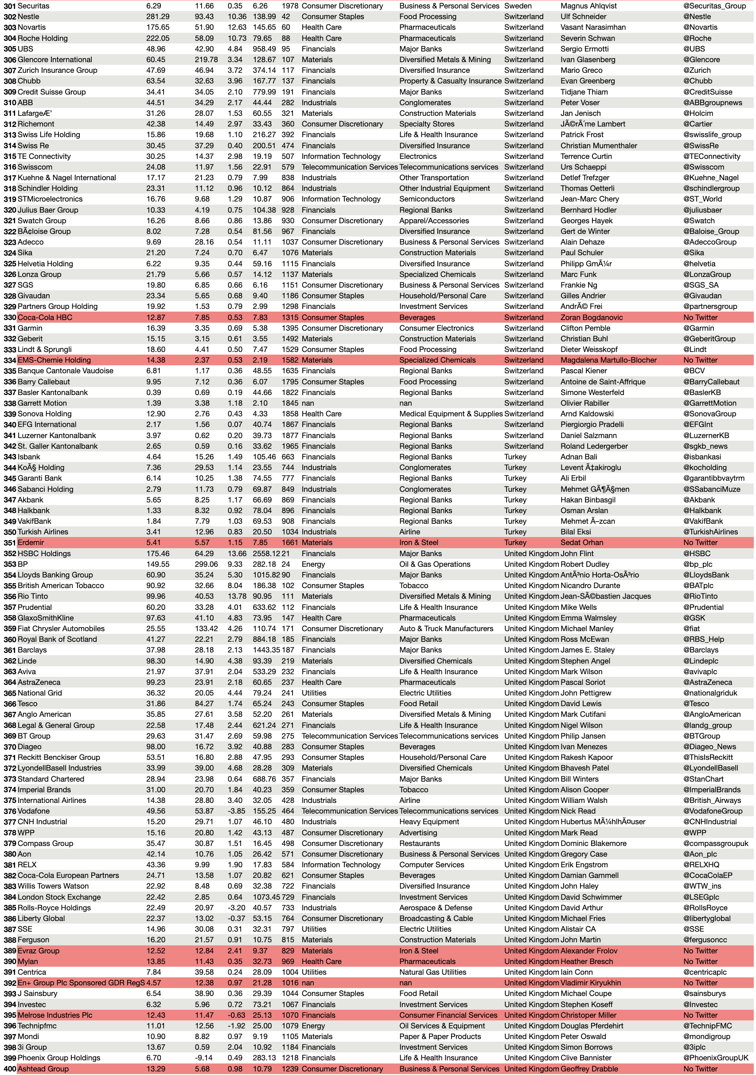

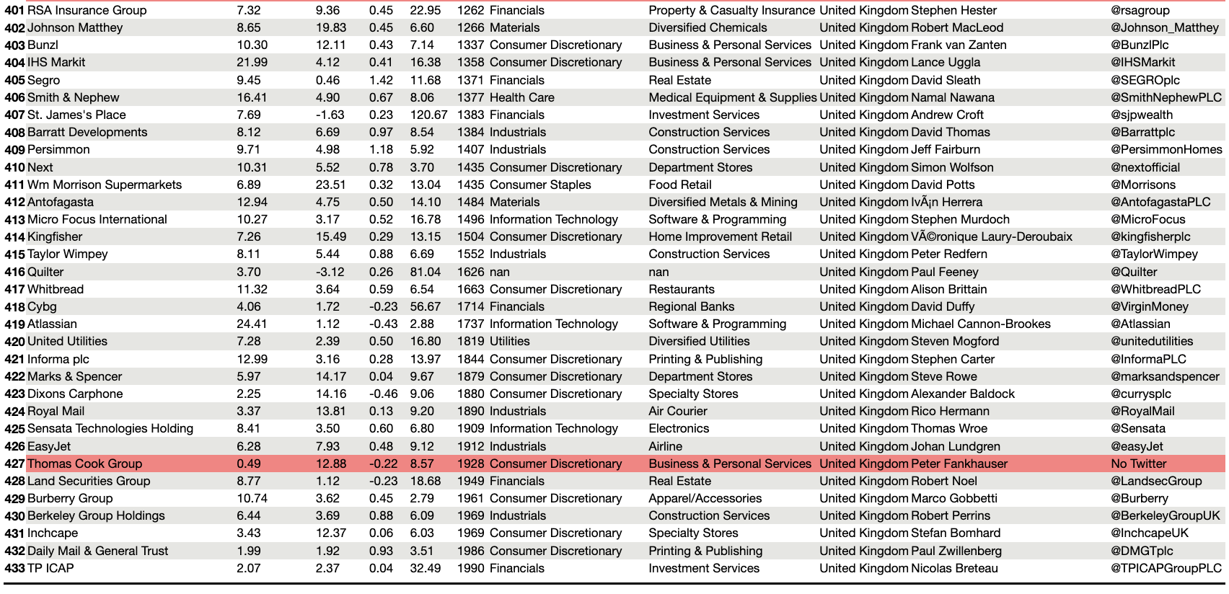

**Appendix B: Code**

The code is also available in a public GitHub repository:

<https://github.com/fabioklr/master_thesis.git>

B.1: R code to filter organic tweets

1. twitter_filenames <- list.files(pattern = 'tweets_unternehmen[1-8].RData')
2. lapply(twitter_filenames, load, .GlobalEnv)
4. tweets_unternehmen <- ls(pattern = "tweets_unternehmen[1-8]")
5. company_tweets <- data.frame()
6. for (i in 1:8) {
7. print(paste(i, "start"))
8. d <- get(tweets_unternehmen[i])[c('author_id', 'created_at', 'id', 'lang', 'referenced_tweets', 'text')]
9. for (j in 1:nrow(d)) {
10. if (is.null(d$referenced_tweets[[j]][1, 1])) {
11. d$reference[j] <- "keep"
12. }
13. else if (d$referenced_tweets[[j]][1, 1] == "quoted" |
14. d$referenced_tweets[[j]][1, 1] == "retweeted") {
15. d$reference[j] <- "discard"
16. }
17. else if (d$referenced_tweets[[j]][1, 1] == "replied_to") {
18. d$reference[j] <- "discard"
19. }
20. print(j)
21. }
22. d <- d[d$reference == "keep",]
23. d[, c('referenced_tweets', 'reference')] <- list(NULL)
24. company_tweets <- rbind(company_tweets, d)
25. print(paste(i, "end")))
26. }
28. # Test code with random sample toy data
29. toy <- data.frame()
30. for (i in 1:8) {
31. d <- get(tweets_unternehmen[i])[c('author_id', 'created_at', 'id', 'lang', 'referenced_tweets', 'text')]
32. toy <- rbind(toy, d[sample(1:nrow(d), 100),])
33. }
35. for (j in 1:nrow(toy)) {
36. if (is.null(toy$referenced_tweets[[j]][1, 1])) {
37. toy$reference[j] <- "keep"
38. }
39. else if (toy$referenced_tweets[[j]][1, 1] == "quoted") {
40. toy$reference[j] <- "keep"
41. }
42. else if (toy$referenced_tweets[[j]][1, 1] == "retweeted") {
43. toy$reference[j] <- "keep"
44. }
45. else {
46. toy$reference[j] <- "discard"
47. }
48. }
50. toy <- toy[toy$reference == "keep",]
51. toy <- subset(toy, select = -reference)
52. save(toy, file = "toy.RData")

B.2 Clean and translate all tweets

1. """Preprocess Twitter data.
3. To use this script, gain access to the Twitter and DeepL APIs on the respective websites. Then, create a file named "keys.py" and place it in the working directory.
4. In "keys.py" define the Twitter API's consumer_key and consumer_secret as well as the access_token and access_token_secret. Also define a variable called
5. "authentication_key" and assign it to the key of the DeepL API.
6. """
8. import pandas as pd
9. import os
10. from preprocessor import tokenize
11. from multiprocessing import Pool
12. from time import time
13. from tweepy import OAuthHandler, API
14. from torch import save, load
15. from deepl import Translator
16. from re import findall
17. from ekphrasis.classes.segmenter import Segmenter
18. from keys import *
19. from transformers import AutoTokenizer, AutoModelForSeq2SeqLM
21. # Set pandas options.
22. pd.set_option('display.min_rows', 400)
23. pd.set_option('display.max_rows', 400)
24. pd.set_option('display.max_columns', None)
25. pd.set_option('display.max_colwidth', 100)
26. pd.set_option('display.width', 1000)
27. pd.set_option('display.colheader_justify', 'center')
28. pd.set_option('display.precision', 3)
30. # def read_feather_in_chunks(filepath):
31. # with ipc.RecordBatchFileReader(filepath) as reader:
32. # for batch_index in range(reader.num_record_batches):
33. # batch = reader.get_batch(batch_index)
34. # print(f'Read in batch {batch_index} which had {batch.num_rows} rows')
35. # data_df = batch.to_pandas(use_threads=True, timestamp_as_object=True, )
36. # yield data_df
38. # Clean text, and find, split and replace hashtags.
39. seg_tw = Segmenter(corpus = "twitter")
40. def clean(tweet_text):
41. hashtags = findall(r"#(\w+)", tweet_text)
42. tweet_text = tokenize(tweet_text)
43. if hashtags:
44. hashtags = [seg_tw.segment(hashtag) for hashtag in hashtags]
45. while hashtags:
46. tweet_text = tweet_text.replace('$HASHTAG$', hashtags.pop(0), 1)
47. return tweet_text
49. def main():
50. startTime = time()
52. # Import tweets and remove those whose language is undefined or not translatable
53. tweets = pd.read_feather('data/organic_tweets.feather')
54. # tweets = tweets.sample(n = 400)
56. if 'processed_text' not in tweets.columns:
57. del tweets['Unnamed: 0']
59. # Filter languages with less than 100 tweets
60. langs_less_than_hundred = [lang for lang, size in tweets.groupby('lang').size().iteritems() if size < 100]
61. tweets = tweets[-tweets['lang'].isin(langs_less_than_hundred)]
63. # Filter languages that are undefined or with a non-Latin alphabet
64. tweets = tweets[-tweets['lang'].isin(['und', 'iw', 'ja', 'ar', 'zh', 'th', 'ko', 'el'])]
66. # Filter authors with less than 100 tweets
67. authors_less_than_hundred = [id for id, size in tweets.groupby('author_id').size().iteritems() if size < 100]
68. tweets = tweets[-tweets['author_id'].isin(authors_less_than_hundred)]
70. pool = Pool()
71. result = pool.map(clean, tweets.text.values.tolist())
72. pool.close()
73. pool.join()
75. tweets['processed_text'] = result
77. # Remove duplicate rows, i.e. keep only one of multiple tweets with identical author_id and text.
78. tweets = tweets.drop_duplicates(subset = ['author_id', 'processed_text'], ignore_index = True)
80. # Remove tweets that are too long for Helsinki University translation models and reset the index.
81. tweets = tweets[-(tweets.processed_text.str.len() > 512)]
82. tweets = tweets.reset_index(drop = True)
84. # Get and add Twitter screen handles - the modifiable Twitter "name" seen by users -
85. # to corresponding rows
86. if 'screen_handle' not in tweets.columns:
87. auth = OAuthHandler(consumer_key, consumer_secret)
88. auth.set_access_token(access_token, access_token_secret)
89. api = API(auth)
91. twitter_ids = set(tweets.author_id)
92. id_to_handle = {}
94. for id in twitter_ids:
95. print(id)
96. handle = api.get_user(user_id = id).screen_name
97. id_to_handle[id] = handle
99. for row in tweets.itertuples():
100. tweets.at[row.Index, 'screen_handle'] = id_to_handle[row.author_id]
102. # Translate raw tweets
103. # Find out translation cost by calculating total number of characters in non-English tweets
104. tweet_lengths = [len(element) for element in tweets.loc[tweets['lang'] != 'en'].text.tolist()]
105. total_n_char = float(sum(tweet_lengths))
106. cost_million_chars = 20
107. print("As of December 2021, translating all non-English tweets with the DeepL API would cost EUR", total_n_char / 1000000 * cost_million_chars - 10)
109. # Translate Roman and other languages with Helsinki models, and the rest with DeepL.
110. roman_langs = ['pt', 'fr', 'it', 'es', 'ca']
111. helsinki_langs = ['de', 'sv', 'da', 'tr', 'fi', 'pl', 'et', 'nl', 'vi']
112. other_langs = [lang for lang in set(tweets.lang) if lang not in roman_langs and lang not in helsinki_langs and lang != 'en']
113. lang_groups = tweets.groupby('lang')
114. translator = Translator(authentication_key) # Initiate DeepL.
115. if 'translated' not in tweets.columns:
116. tweets['translated'] = False
118. try:
119. os.makedirs(f'{(cwd := os.getcwd())}/models/Helsinki-NLP')
120. except Exception:
121. pass
123. def translate():
124. for lang, group in lang_groups:
125. print(lang)
126. if lang in roman_langs:
127. if os.path.isfile(f'{cwd}/models/Helsinki-NLP/opus-mt-ROMANCE-en.pt'):
128. roman_tokenizer = load(f'{cwd}/models/Helsinki-NLP/opus-mt-ROMANCE-en_tokenizer.pt')
129. roman_model = load(f'{cwd}/models/Helsinki-NLP/opus-mt-ROMANCE-en.pt')
130. else:
131. roman_tokenizer = AutoTokenizer.from_pretrained('Helsinki-NLP/opus-mt-ROMANCE-en')
132. save(roman_tokenizer, f'{cwd}/models/Helsinki-NLP/opus-mt-ROMANCE-en_tokenizer.pt')
133. roman_model = AutoModelForSeq2SeqLM.from_pretrained('Helsinki-NLP/opus-mt-ROMANCE-en')
134. save(roman_model, f'{cwd}/models/Helsinki-NLP/opus-mt-ROMANCE-en.pt')
135. for row in group.itertuples():
136. if not group.at[row.Index, 'translated']:
137. batch = roman_tokenizer([row.processed_text], return_tensors="pt", padding=True)
138. translation = roman_model.generate(**batch)
139. group.at[row.Index, 'processed_text'] = roman_tokenizer.batch_decode(translation, skip_special_tokens=True)[0]
140. elif lang in helsinki_langs:
141. model_name = f'Helsinki-NLP/opus-mt-{lang}-en'
142. if os.path.isfile(f'{cwd}/models/{model_name}.pt'):
143. tokenizer = load(f'{cwd}/models/{model_name}_tokenizer.pt')
144. model = load(f'{cwd}/models/{model_name}.pt')
145. else:
146. tokenizer = AutoTokenizer.from_pretrained(model_name)
147. save(tokenizer, f'{cwd}/models/{model_name}_tokenizer.pt')
148. model = AutoModelForSeq2SeqLM.from_pretrained(model_name)
149. save(model, f'{cwd}/models/{model_name}.pt')
150. for row in group.itertuples():
151. if not group.at[row.Index, 'translated']:
152. batch = tokenizer([row.processed_text], return_tensors="pt", padding=True)
153. translation = model.generate(**batch)
154. group.at[row.Index, 'processed_text'] = tokenizer.batch_decode(translation, skip_special_tokens=True)[0]
155. elif lang in other_langs:
156. for row in group.itertuples():
157. if not group.at[row.Index, 'translated']:
158. group.at[row.Index, 'processed_text'] = translator.translate_text(row.processed_text, target_lang = "EN-GB").text
160. yield group
162. generator = translate()
163. for group in generator:
164. for row in group.itertuples():
165. if not tweets.at[row.Index, 'translated']:
166. tweets.at[row.Index, 'processed_text'] = row.processed_text
167. tweets.at[row.Index, 'translated'] = True
169. for row in tweets.itertuples():
170. editing = tweets.at[row.Index, 'processed_text'].split()
171. new_processed = [word for word in editing if '$' not in word]
172. tweets.at[row.Index, 'processed_text'] = ' '.join(new_processed)
174. tweets.to_feather('data/preprocessed_tweets.feather')
176. print(len(tweets))
177. executionTime = time() - startTime
178. print(f'Execution time in seconds: {executionTime}')
180. if __name__ == '__main__':
181. main()

B.3 Embedding, Dimensionality Reduction and Clustering

1. """Clustering.
2. """
4. import pandas as pd
5. import os
6. import pickle
7. import matplotlib.pyplot as plt
8. import numpy as np
9. import csv
10. from hdbscan import HDBSCAN
11. from time import time
12. from umap import UMAP
13. from torch import save, load
14. from sentence_transformers import SentenceTransformer
15. from sklearn.feature_extraction.text import CountVectorizer
16. from resource import getrusage, RUSAGE_SELF
18. def compute_sentence_embeddings(tweets, model_name):
19. if os.path.isfile(f'{(cwd := os.getcwd())}/models/{model_name}.pt'):
20. model = load(f'{cwd}/models/{model_name}.pt')
21. else:
22. model = SentenceTransformer(model_name)
23. os.mkdir(f'{cwd}/models')
24. save(model, f'{cwd}/models/{model_name}.pt')
26. embeddings = model.encode(tweets.processed_text.values, show_progress_bar = True)
28. #Store sentences & embeddings on disc
29. with open('data/embeddings.pkl', "wb") as fOut:
30. pickle.dump({'embeddings': embeddings}, fOut, protocol = pickle.HIGHEST_PROTOCOL)
32. return embeddings
34. def c_tf_idf(documents, m, ngram_range = (1, 1)):
35. count = CountVectorizer(ngram_range = ngram_range, stop_words="english").fit(documents)
36. t = count.transform(documents).toarray()
37. w = t.sum(axis = 1)
38. tf = np.divide(t.T, w)
39. sum_t = t.sum(axis = 0)
40. idf = np.log(np.divide(m, sum_t)).reshape(-1, 1)
41. tf_idf = np.multiply(tf, idf)
43. return tf_idf, count
45. def extract_top_n_words_per_topic(tf_idf, count, docs_per_topic, n = 20):
46. words = count.get_feature_names()
47. labels = list(docs_per_topic.topic) # changed '.Topic'
48. tf_idf_transposed = tf_idf.T
49. indices = tf_idf_transposed.argsort()[:, -n:]
50. top_n_words = {label: [(words[j], tf_idf_transposed[i][j]) for j in indices[i]][::-1] for i, label in enumerate(labels)}
52. return top_n_words
54. def extract_topic_sizes(df):
55. topic_sizes = (df.groupby(['topic'])
56. .processed_text
57. .count()
58. .reset_index()
59. .rename({"topic": "Topic", "processed_text": "Size"}, axis='columns')
60. .sort_values("Size", ascending=False))
62. return topic_sizes
64. def main():
65. startTime = time()
66. tweets = pd.read_feather('data/preprocessed_tweets.feather')
67. del tweets['translated']
68. # tweets = tweets.sample(frac = 0.2, random_state = 123)
69. # tweets_test = tweets.drop(tweets.index).sample(frac = 1, random_state = 124)
70. # del tweets
72. if os.path.isfile(f'{(cwd := os.getcwd())}/data/embeddings.pkl'):
73. #Load sentences & embeddings from disc
74. with open('data/embeddings.pkl', "rb") as fIn:
75. stored_data = pickle.load(fIn)
76. embeddings = stored_data['embeddings']
77. else:
78. embeddings = compute_sentence_embeddings(tweets = tweets, model_name = 'all-MiniLM-L6-v2')
80. if os.path.isfile(f'{cwd}/data/umap_embeddings.pkl'):
81. with open('data/umap_embeddings.pkl', "rb") as fIn:
82. stored_data = pickle.load(fIn)
83. umap_embeddings = stored_data['umap_embeddings']
84. else:
85. # Reduce dimensionality.
86. dimensionality_reducer = UMAP(n_components = 10, n_neighbors = 100, min_dist = 0.01, verbose = True, low_memory = True)
87. umap_embeddings = dimensionality_reducer.fit_transform(embeddings)
88. with open('data/umap_embeddings.pkl', 'wb') as fOut:
89. pickle.dump({'umap_embeddings': umap_embeddings}, fOut, protocol = pickle.HIGHEST_PROTOCOL)
91. # Cluster vectors.
92. cluster_model = HDBSCAN(min_cluster_size = 7000, min_samples = 30, cluster_selection_method = 'leaf', core_dist_n_jobs = 1)
93. cluster = cluster_model.fit(umap_embeddings)
94. tweets['topic'] = cluster.labels_
96. docs_per_topic = tweets.groupby(['topic'], as_index = False).agg({'processed_text': ' '.join})
97. tf_idf, count = c_tf_idf(docs_per_topic.processed_text.values, m = len(tweets))
98. top_n_words = extract_top_n_words_per_topic(tf_idf, count, docs_per_topic, n = 10)
99. w = csv.writer(open('data/top_n_words_per_topic.csv', 'w'))
100. for key, val in top_n_words.items():
101. w.writerow([key, val])
103. tweets['topic_top_words'] = ''
104. tweets['topic_top_words'] = tweets['topic_top_words'].astype(object)
105. for row in tweets.itertuples():
106. tweets.at[row.Index, 'topic_top_words'] = [top_n_words[row.topic][i][0] for i in range(5)]
108. tweets = tweets.reset_index()
109. tweets.to_feather('data/final_tweets.feather')
111. print(f'Maximum memory used: {getrusage(RUSAGE_SELF).ru_maxrss}')
112. print(f'Execution time in seconds: {time() - startTime}')
114. main()

B.3 Analysis: Figures and Tables

1. import os
2. import pandas as pd
3. import numpy as np
4. import matplotlib as mpl
5. import plotly.express as px
7. pd.set_option('display.min_rows', 400)
8. pd.set_option('display.max_rows', 400)
9. pd.set_option('display.max_columns', None)
10. pd.set_option('display.max_colwidth', 100)
11. pd.set_option('display.width', 1000)
12. pd.set_option('display.colheader_justify', 'center')
13. pd.set_option('display.precision', 3)
15. mpl.rcParams['figure.dpi'] = 75
17. # Convert the 'created_at' strings to datetime and then ISO calendar values. The ISO calendar is based on years, weeks and days.
18. # Then update the 'created_at' column with simple strings representing the year and week, e.g. '2018-05', and exclude potential tweets from outside our period.
19. tweets = pd.read_feather('data/final_tweets.feather')
20. year_week = pd.to_datetime(tweets.created_at.values, dayfirst = True).isocalendar()
21. tweets['created_at'] = [f'{year_week.iat[idx, 0]}-{str(year_week.iat[idx, 1]).zfill(2)}' for idx in range(len(year_week))]
22. tweets = tweets[tweets.created_at.isin(['2019-48', '2019-49', '2019-50', '2019-51', '2019-52']) == False]
24. # Create a column in the tweets dataframe that indicates whether a given tweet was made before or after the beginning of FFF protests.
25. pre = sorted(tweets.created_at.unique())[:38]
26. tweets['period'] = ['Pre FFF' if row.created_at in pre else 'Post FFF' for row in tweets.itertuples()]
28. # Import and adapt the companies dataframe, define variables used in multiple subsequent cells.
29. companies = pd.read_csv('data/Forbes_global_2000_2019.csv')
30. companies = companies[companies['Continent'] == 'Europe']
31. unique_countries = np.append(companies.Country.unique(), 'Total')
32. for idx, ele in enumerate(unique_countries):
33. if unique_countries[idx] == 'United Kingdom':
34. unique_countries[idx] = 'UK'
35. elif unique_countries[idx] == 'Czech Republic':
36. unique_countries[idx] = 'Czechia'
38. # Define rows in tables to be shaded grey or colored red.
39. idx_grey = pd.IndexSlice
40. slice_grey = idx_grey[::2, :]
41. idx_no_twitter = pd.IndexSlice
42. slice_no_twitter = idx_no_twitter[companies['Twitter ID'] == 'No Twitter', :]
44. topic_names = ['Non-category', 'Health', 'Cars', 'Sports', 'Diversity', 'Financial results', 'Economics', 'Financial services', 'Customer service', \
45. 'Food & Holidays', 'Luxury', 'Travel', 'IT infrastructure', 'Future mobility', 'Sustainability', 'Artificial Intelligence', 'Innovation']

Visualisded Approach

1. from diagrams import Cluster, Diagram
2. from diagrams.saas.social import Twitter
3. from diagrams.custom import Custom
5. graph_attr = {
6. "bgcolor": "transparent"
7. }
9. with Diagram('', filename='visualised_approach', show=False, graph_attr=graph_attr, direction='LR'):
10. tw = Twitter('Input Tweet')
11. topics = Custom('Topics', './icons/boxes.png')
13. with Cluster('Preprocess', graph_attr=graph_attr):
14. cleaning = Custom('Cleaning', './icons/clean.png')
15. translating = Custom('Translating', './icons/helsinki_nlp.png')
16. cleaning >> translating
18. with Cluster('Embedding & Clustering', graph_attr=graph_attr):
19. embedding = Custom('Embedding', './icons/hugging_face.png')
20. reducing = Custom('Dimensionality Reduction', './icons/umap.png')
21. clustering = Custom('Clustering', './icons/hdbscan.png')
22. embedding >> reducing >> clustering
24. tw >> cleaning >> embedding >> topics

Forbes Global 2000 European companies complete and small table

1. # 2019 Forbes Global 2000 European companies complete table
2. companies.style.hide(['Forbes Webpage', 'Profits as % of Assets', 'Profits as % of Revenue', 'Continent', 'Headquarters'], axis = 'columns')\
3. .format(precision = 2)\
4. .set_properties(**{'background-color': '#e6e6e3'}, subset = slice_grey)\
5. .set_properties(**{'background-color': '#ff7f7f'}, subset = slice_no_twitter)\
6. .set_table_styles([
7. {'selector': '', 'props': 'border-spacing: 0px; border-bottom: 2px solid black; font-size: 8pt; padding-bottom: 5px;'},
8. {'selector': 'th.col_heading', 'props': 'font-family: Helvetica Neue; font-weight: bold; text-align: left; border-top: 2px solid black; border-bottom: 1px solid black; padding-top: 10px; padding-bottom: 5px;'},
9. {'selector': 'th.row_heading', 'props': 'font-family: Helvetica Neue;'},
10. {'selector': 'td', 'props': 'border-width: 0px; font-family: Helvetica Neue; text-align: left;'}])\
11. .to_html(buf = f'{os.getcwd()}/forbes_complete.html')
13. # 2019 Forbes Global 2000 European companies small table
14. companies_sample = companies.sample(10, random_state = 123)
15. companies_sample.style.hide()\
16. .hide(['Forbes Webpage', 'Profits as % of Assets', 'Profits as % of Revenue', 'Continent', 'Headquarters'], axis = 'columns')\
17. .format(precision = 2)\
18. .set_properties(**{'background-color': '#e6e6e3'}, subset = slice_grey)\
19. .set_properties(**{'background-color': '#ff7f7f'}, subset = slice_no_twitter)\
20. .set_table_styles([
21. {'selector': '', 'props': 'border-spacing: 0px; border-bottom: 2px solid black; font-size: 8pt; padding-bottom: 5px;'},
22. {'selector': 'th', 'props': 'font-family: Helvetica Neue; font-weight: bold; text-align: left; border-top: 2px solid black; border-bottom: 1px solid black; padding-top: 10px; padding-bottom: 5px;'},
23. {'selector': 'td', 'props': 'border-width: 0px; font-family: Helvetica Neue; text-align: left;'}])\
24. .to_html(buf = f'{os.getcwd()}/forbes_small.html')

Fridays for Future table

1. fff_18 = pd.read_csv('data/FFF_global_2018.csv')
2. fff_18 = fff_18.set_index('Unnamed: 0')
3. fff_18.index.name = None
4. fff_18.columns = pd.to_datetime(fff_18.columns.values, dayfirst = True).isocalendar()
5. fff_18 = fff_18.filter(items = unique_countries, axis = 0)
6. fff_18 = fff_18.groupby(fff_18.columns, axis = 1).agg(lambda x: x.apply(lambda y: sum([l for l in y if str(l) != "nan"]), axis = 1))
8. fff_19 = pd.read_csv('data/FFF_global_2019.csv')
9. fff_19 = fff_19.set_index('Unnamed: 0')
10. fff_19.index.name = None
11. fff_19 = fff_19.filter(items = unique_countries, axis = 0).drop(['01.12.19', '08.12.19', '15.12.19', '22.12.19', '29.12.19', '05.01.20'], axis = 1)
12. fff_19.columns = pd.to_datetime(fff_19.columns.values, dayfirst = True).isocalendar()
13. fff_19 = fff_19.groupby(fff_19.columns, axis = 1).agg(lambda x: x.apply(lambda y: sum([l for l in y if str(l) != "nan"]), axis = 1))
15. fff = pd.concat([fff_18, fff_19], axis = 1)
16. fff = fff.groupby(fff.columns, axis = 1).agg(lambda x: x.apply(lambda y: sum([l for l in y if str(l) != "nan"]), axis = 1))
17. fff.columns = ['-'.join(tuple(str(num).zfill(2) for num in tup[:2])) for tup in fff.columns.values]
19. fff.style.format(precision = 0)\
20. .set_properties(**{'background-color': '#e6e6e3'}, subset = slice_grey)\
21. .applymap(lambda v, props='color: rgba(0,0,0,0);': props if v == 0 else None)\
22. .set_table_styles([
23. {'selector': '', 'props': 'border-spacing: 0px; border-top: 2px solid black; border-bottom: 2px solid black; font-size: 6pt; padding-bottom: 5px;'},
24. {'selector': 'th.col_heading', 'props': 'font-family: Helvetica Neue; font-weight: bold; text-align: left; border-bottom: 1px solid black; padding-top: 10px; padding-bottom: 5px; min-width: 35px;'},
25. {'selector': 'th.row_heading', 'props': 'font-family: Helvetica Neue;'},
26. {'selector': 'td', 'props': 'border-width: 0px; font-family: Helvetica Neue; text-align: left;'}])\
27. .to_html(buf = f'{os.getcwd()}/fff.html')

UMAP fire graph

1. import umap.plot
2. import pickle
3. from umap import UMAP
5. if os.path.isfile(f'{(cwd := os.getcwd())}/data/embeddings.pkl'):
6. with open('data/embeddings.pkl', "rb") as fIn:
7. stored_data = pickle.load(fIn)
8. embeddings = stored_data['embeddings']
10. umap_embeddings_plot = UMAP(n_components = 2, n_neighbors = 100, min_dist = 0.01, verbose = True, low_memory = True).fit(embeddings)
11. umap.plot.points(umap_embeddings_plot, labels=tweets.topic, theme='fire')

Topics table

1. topics = pd.read_csv('data/top_n_words_per_topic.csv', header=None)
2. del topics[0]
3. topics.reindex(columns=range(1, 11))
4. for row in topics.itertuples():
5. adapted_row = topics.at[row.Index, 1].split('(')
6. adapted_row.remove('[')
7. topics.at[row.Index, 1] = [ele.split(',')[0][1:-1] for ele in adapted_row]
8. for idx in reversed(range(1, 11)):
9. topics.at[row.Index, idx] = topics.at[row.Index, 1].pop()
11. topics = topics.set_index(pd.Index(range(-1, 16)))
12. topics = topics[sorted(topics.columns)]
13. topics['Topic name'] = topic_names
15. topics.style.format(precision = 0)\
16. .set_properties(**{'background-color': '#e6e6e3'}, subset = slice_grey)\
17. .applymap(lambda v, props='color: rgba(0,0,0,0);': props if v == 0 else None)\
18. .set_table_styles([
19. {'selector': '', 'props': 'border-spacing: 0px; border-top: 2px solid black; border-bottom: 2px solid black; font-size: 8pt; padding-bottom: 5px;'},
20. {'selector': 'th.col_heading', 'props': 'font-family: Helvetica Neue; font-weight: bold; text-align: left; border-bottom: 1px solid black; padding-top: 10px; padding-bottom: 5px;'},
21. {'selector': 'th.row_heading', 'props': 'font-family: Helvetica Neue;'},
22. {'selector': 'td.data.col10', 'props': 'font-weight: bold;'},
23. {'selector': 'td', 'props': 'border-width: 0px; font-family: Helvetica Neue; text-align: left;'}])\
24. .to_html(buf = f'{os.getcwd()}/topics.html')

Overall protests and tweeting

1. # Here we create a df that is the basis of our graphs. Its index are all weeks considered and its columns are defined one after the other.
2. general_date = pd.DataFrame(tweets.groupby('created_at').size(), columns=['total_tweets'])
3. general_date.index.rename('week', inplace=True)
4. general_date['sustainability_tweets'] = tweets.loc[tweets['topic'] == 13].groupby('created_at').size()
5. general_date['sustainability_share'] = general_date['sustainability_tweets'] / general_date['total_tweets']
6. general_date['total_protesters'] = fff.iloc[-1]
7. general_date['total_protesters'] = general_date['total_protesters'].fillna(0).astype('Int64')
8. general_date = general_date.reset_index()
9. general_date['week'] = general_date['week'].astype(str)
11. general_pre_fff_median = general_date.iloc[:38]['sustainability_share'].median().round(3)
12. general_post_fff_median = general_date.iloc[38:]['sustainability_share'].median().round(3)
14. px.line(general_date, x="week", y="sustainability_share", height=500, width=1000, color_discrete_sequence=['black'])\
15. .update_layout(title=dict(text='Share of corporate tweets related to sustainability', font=dict(family='Helvetica Neue', color='black')),
16. xaxis_title=dict(text='Week', font=dict(family='Helvetica Neue', color='black')),
17. xaxis=dict(tickfont=dict(family='Helvetica Neue', color='black'), type='category'),
18. yaxis_title=dict(text='Percentage of tweets', font=dict(family='Helvetica Neue', color='black')),
19. yaxis=dict(tickfont=dict(family='Helvetica Neue', color='black'), tickformat='.0%'),
20. autosize=False,
21. plot_bgcolor='#e6e6e3')\
22. .add_shape(type="line", x0=0, y0=general_pre_fff_median, x1='2018-33', y1=general_pre_fff_median, line=dict(color='#C84B31', dash="dashdot"))\
23. .add_shape(type="line", x0='2018-35', y0=general_post_fff_median, x1='2019-47', y1=general_post_fff_median, line=dict(color='#C84B31', dash="dashdot"))\
24. .add_annotation(x='2019-37', y=0.065, text="Post FFF median", font=dict(family='Helvetica Neue', color='#C84B31'), showarrow=False)\
25. .add_annotation(x='2018-04', y=0.057, text="Pre FFF median", font=dict(family='Helvetica Neue', color='#C84B31'), showarrow=False)\
26. .add_vrect(x0="2018-34", x1="2018-35", annotation_text="FFF protests start", annotation_font_family='Helvetica Neue', annotation_position="top left",
27. fillcolor="black", opacity=0.25, line_width=0, annotation=dict(font_color='black'))\
28. .show()
30. px.line(general_date, x="week", y="total_protesters", height=500, width=1000)\
31. .update_layout(title=dict(text='FFF protesters in selected European countries per week', font=dict(family='Helvetica Neue', color='black')),
32. xaxis_title=dict(text='Week', font=dict(family='Helvetica Neue', color='black')),
33. xaxis=dict(tickfont=dict(family='Helvetica Neue', color='black'), type='category'),
34. yaxis_title=dict(text='Number of protesters', font=dict(family='Helvetica Neue', color='black')),
35. yaxis=dict(tickfont=dict(family='Helvetica Neue', color='black')),
36. autosize=False,
37. plot_bgcolor='#e6e6e3')\
38. .add_vrect(x0="2018-34", x1="2018-35", annotation_text="FFF protests start", annotation_font_family='Helvetica Neue', annotation_position="top left",
39. fillcolor="black", opacity=0.25, line_width=0, annotation=dict(font_color='black'))\
40. .update_traces(line_color='black')\
41. .show()
43. from scipy.stats import pearsonr
45. r, p = pearsonr(general_date['sustainability_share'], general_date['total_protesters'])
46. print('Pearsons correlation: %.3f' % r)
47. print('The p-value is: %.20f' % p)

B2B and B2C differences

1. # Create a column in the tweets dataframe with the respective company name.
2. ids = [id[1:] for id in companies['Twitter ID'].values]
3. handle_to_name = pd.Series(companies.Company.values, index=ids).to_dict()
4. tweets['company'] = [handle_to_name[handle] for handle in tweets.screen_handle.values]
6. # All industries in the Materials and Industrials sectors minus 'Airline', 'Conglomerate' and 'Air Courier'
7. b2b_industries = ['Iron & Steel', 'Construction Services', 'Diversified Chemicals', 'Diversified Metals & Mining',
8. 'Other Transportation', 'Electrical Equipment', 'Trucking', 'Paper & Paper Products',
9. 'Heavy Equipment', 'Specialized Chemicals', 'Aerospace & Defense', 'Construction Materials',
10. 'Other Industrial Equipment', 'Aluminum']
12. # All industries in the Consumer Discretionary and Consumer Staples sectors minus 'Business and Personal Services', 'Advertising'
13. b2c_industries = ['Beverages', 'Food Retail', 'Apparel/Accessories', 'Household/Personal Care',
14. 'Auto & Truck Manufacturers', 'Food Processing', 'Auto & Truck Parts', 'Hotels & Motels',
15. 'Household Appliances', 'Department Stores', 'Specialty Stores', 'Apparel/Footwear Retail',
16. 'Broadcasting & Cable', 'Furniture & Fixtures', 'Printing & Publishing', 'Consumer Electronics',
17. 'Tobacco', 'Restaurants', 'Home Improvement Retail']
19. # Create a column in the tweets dataframe indicating whether a given tweet stems from a b2b, b2c or other company.
20. b2b_companies = companies.loc[companies['Industry'].isin(b2b_industries)].Company.values
21. b2c_companies = companies.loc[companies['Industry'].isin(b2c_industries)].Company.values
22. context = []
23. for company in tweets['company']:
24. if company in b2b_companies:
25. context.append('B2B')
26. elif company in b2c_companies:
27. context.append('B2C')
28. else:
29. context.append('other')
31. tweets['context'] = context
33. b2b_b2c_test = pd.DataFrame(tweets.groupby(['context', 'company']).size(), columns=['total_tweets']).reset_index()
34. b2b_b2c_test = b2b_b2c_test.loc[b2b_b2c_test['context'] != 'other']
36. sus_tweets = []
37. b2b_b2c_sus_tweets = pd.DataFrame(tweets.groupby(['context', 'company', 'topic']).size()).reset_index()
38. b2b_b2c_sus_tweets = b2b_b2c_sus_tweets[b2b_b2c_sus_tweets['topic'] == 13]
39. for company in b2b_b2c_test.company:
40. try:
41. num_of_sus_tweets = int(b2b_b2c_sus_tweets[b2b_b2c_sus_tweets['company'] == company][0])
42. sus_tweets.append(num_of_sus_tweets)
43. except TypeError:
44. sus_tweets.append(0)
46. b2b_b2c_test['sustainability_tweets'] = sus_tweets
47. b2b_b2c_test['sustainability_share'] = (b2b_b2c_test['sustainability_tweets'] / b2b_b2c_test['total_tweets']).round(3)
49. summary = b2b_b2c_test[b2b_b2c_test['context'] == 'B2B']['sustainability_tweets'].describe().to_frame()
50. summary = summary.rename(columns={'sustainability_tweets': 'B2B absolute sustainability tweets'})
51. summary['B2B relative sustainability tweets'] = b2b_b2c_test[b2b_b2c_test['context'] == 'B2B']['sustainability_share'].describe().to_frame().sustainability_share
52. summary['B2C absolute sustainability tweets'] = b2b_b2c_test[b2b_b2c_test['context'] == 'B2C']['sustainability_tweets'].describe().to_frame().sustainability_tweets
53. summary['B2C relative sustainability tweets'] = b2b_b2c_test[b2b_b2c_test['context'] == 'B2C']['sustainability_share'].describe().to_frame().sustainability_share
54. summary['B2B absolute sustainability tweets'] = summary['B2B absolute sustainability tweets'].astype(int)
55. summary['B2C absolute sustainability tweets'] = summary['B2C absolute sustainability tweets'].astype(int)
57. summary.style.format(precision = 3)\
58. .set_properties(**{'background-color': '#e6e6e3'}, subset = slice_grey)\
59. .set_table_styles([
60. {'selector': '', 'props': 'border-spacing: 0px; border-top: 2px solid black; border-bottom: 2px solid black; font-size: 6pt; padding-bottom: 5px;'},
61. {'selector': 'th.col_heading', 'props': 'font-family: Helvetica Neue; font-weight: bold; text-align: left; border-bottom: 1px solid black; padding-top: 10px; padding-bottom: 5px; padding-left: 10px; min-width: 35px;'},
62. {'selector': 'th.row_heading', 'props': 'font-family: Helvetica Neue;'},
63. {'selector': 'td', 'props': 'border-width: 0px; font-family: Helvetica Neue; text-align: left; text-align: center;'}])\
64. .to_html(buf = f'{os.getcwd()}/b2b_b2c_summary.html')
66. def create_context_date_table(context):
67. context_date_table = pd.DataFrame(tweets.loc[tweets['context'] == context].groupby('created_at').size(), columns=['total_tweets'])
68. context_date_table.index.rename('week', inplace=True)
69. context_date_table['sustainability_tweets'] = tweets.loc[(tweets['context'] == context) & (tweets['topic'] == 13)].groupby('created_at').size()
70. context_date_table['sustainability_share'] = context_date_table['sustainability_tweets'] / context_date_table['total_tweets']
71. context_date_table.reset_index(inplace=True)
72. context_date_table['context'] = context
73. context_date_table['week'] = context_date_table['week'].astype(str)
74. pre_fff_median = context_date_table.iloc[:38]['sustainability_share'].median().round(3)
75. post_fff_median = context_date_table.iloc[38:]['sustainability_share'].median().round(3)
77. return context_date_table, pre_fff_median, post_fff_median
79. b2b_date, b2b_pre_fff_median, b2b_post_fff_median = create_context_date_table('B2B')
80. b2c_date, b2c_pre_fff_median, b2c_post_fff_median = create_context_date_table('B2C')
81. b2b_b2c_date = pd.merge(b2b_date, b2c_date, how='outer')
83. px.line(b2b_b2c_date, x="week", y="sustainability_share", color='context', color_discrete_sequence=['#346751', '#C84B31'], height=500, width=1000)\
84. .update_layout(title=dict(text="B2B and B2C companies' overall shares of sustainability tweets per week", font=dict(family='Helvetica Neue', color='black')),
85. xaxis_title=dict(text='Week', font=dict(family='Helvetica Neue', color='black')),
86. xaxis=dict(tickfont=dict(family='Helvetica Neue', color='black'), type='category'),
87. yaxis_title=dict(text='Share of sustainability tweets', font=dict(family='Helvetica Neue', color='black')),
88. yaxis=dict(tickfont=dict(family='Helvetica Neue', color='black')),
89. autosize=False,
90. plot_bgcolor='#e6e6e3',
91. legend_title=dict(text='Context', font=dict(family='Helvetica Neue', color='black')),
92. legend=dict(font=dict(color='black')))\
93. .add_shape(type="line", x0=0, y0=b2b_pre_fff_median, x1='2018-34', y1=b2b_pre_fff_median, line=dict(color="black", dash="dashdot"))\
94. .add_shape(type="line", x0='2018-35', y0=b2b_post_fff_median, x1='2019-47', y1=b2b_post_fff_median, line=dict(color="black", dash="dashdot"))\
95. .add_shape(type="line", x0=0, y0=b2c_pre_fff_median, x1='2018-34', y1=b2c_pre_fff_median, line=dict(color="black", dash="dashdot"))\
96. .add_shape(type="line", x0='2018-35', y0=b2c_post_fff_median, x1='2019-47', y1=b2c_post_fff_median, line=dict(color="black", dash="dashdot"))\
97. .add_annotation(x='2019-37', y=0.105, text="Post FFF B2B median", font=dict(family='Helvetica Neue', color='black'), showarrow=False)\
98. .add_annotation(x='2018-04', y=0.092, text="Pre FFF B2B median", font=dict(family='Helvetica Neue', color='black'), showarrow=False)\
99. .add_annotation(x='2019-37', y=0.026, text="Post FFF B2C median", font=dict(family='Helvetica Neue', color='black'), showarrow=False)\
100. .add_annotation(x='2018-04', y=0.026, text="Pre FFF B2C median", font=dict(family='Helvetica Neue', color='black'), showarrow=False)\
101. .add_vrect(x0="2018-34", x1="2018-35", annotation_text="FFF protests start", annotation_font_family='Helvetica Neue', annotation_position="top left",
102. fillcolor="black", opacity=0.25, line_width=0, annotation=dict(font_color='black'))\
103. .show()
105. b2b_b2c_count = pd.DataFrame(tweets.groupby(['context', 'period', 'topic']).size()).reset_index()
106. b2b_b2c_count = b2b_b2c_count.loc[b2b_b2c_count['context'] != 'other']
107. b2b_b2c_count['topic'] = b2b_b2c_count['topic'].astype(str)
108. newnames = {str(x):y for x,y in zip(sorted(tweets.topic.unique().tolist()), topic_names)}
110. px.bar(b2b_b2c_count, x=0, y='context', color="topic", facet_row='period', width=1100, category_orders={'context': ['B2B', 'B2C'], 'period': ['Pre FFF', 'Post FFF']},
111. color_discrete_sequence=px.colors.qualitative.T10, orientation='h')\
112. .update_layout(xaxis_title=dict(text='Number of tweets', font=dict(family='Helvetica Neue', color='black')),
113. xaxis=dict(tickfont=dict(family='Helvetica Neue', color='black')),
114. autosize=False,
115. plot_bgcolor='#e6e6e3',
116. legend_title=dict(text=''),
117. legend=dict(orientation='h', yanchor='bottom', y=1, xanchor='right', x=0.9, font=dict(family='Helvetica Neue', color='black')))\
118. .update_yaxes(tickfont=dict(family='Helvetica Neue', color='black'), title=dict(text='', font=dict(family='Helvetica Neue', color='black')))\
119. .for_each_annotation(lambda a: a.update(text=a.text.split("=")[-1], textangle=0, font=dict(family='Helvetica Neue', color='black')))\
120. .for_each_trace(lambda t: t.update(name = newnames[t.name]))\
121. .show()
123. import statsmodels.formula.api as sm
124. from scipy import stats
126. b2b_date = b2b_date[38:]
127. b2b_date['protesters'] = stats.zscore(fff.iloc[-1].astype(int).tolist())
128. b2b_date['sustainability_share'] = stats.zscore(b2b_date['sustainability_share'])
130. b2c_date = b2c_date[38:]
131. b2c_date['protesters'] = stats.zscore(fff.iloc[-1].astype(int).tolist())
132. b2c_date['sustainability_share'] = stats.zscore(b2c_date['sustainability_share'])
134. reg_b2b = sm.ols(formula='sustainability_share ~ protesters', data=b2b_date).fit()
135. print(reg_b2b.summary())
136. reg_b2c = sm.ols(formula='sustainability_share ~ protesters', data=b2c_date).fit()
137. print(reg_b2c.summary())

Borders, a transnational movement and multinational companies

1. company_country_dict = {company: country for company, country in zip(companies['Company'], companies['Country'])}
2. tweets['country'] = [company_country_dict[row.company] for row in tweets.itertuples()]
3. top_countries = [country for country, no_of_companies in companies.groupby('Country').size().iteritems() if no_of_companies > 25]
4. tweets_by_top_countries = tweets[tweets.country.isin(top_countries)]
5. tweets_by_top_countries_13 = tweets[(tweets.country.isin(top_countries)) & (tweets['topic'] == 13)]
7. country_date = pd.DataFrame(tweets_by_top_countries.groupby(['created_at', 'country']).size(), columns=['total_tweets']).reset_index()
8. temp_df = pd.DataFrame(tweets_by_top_countries_13.groupby(['created_at', 'country']).size(), columns=['sust_tweets']).reset_index()
9. country_date = pd.merge(country_date, temp_df, on = ['created_at', 'country'], how = 'outer')
10. country_date.fillna(1, inplace=True)
11. country_date['sust_tweets'] = country_date['sust_tweets'].astype(int)
12. country_date['sust_share'] = country_date['sust_tweets'] / country_date['total_tweets']
14. px.line(country_date, x="created_at", y="sust_share", color='country', color_discrete_sequence= ['#7A7A78', '#1C684E', '#8DB3A7', '#EC9F92', '#D94025', '#732719'],
15. facet_col='country', facet_col_wrap=3, facet_row_spacing=0.12, width=1300, height=900)\
16. .update_layout(plot_bgcolor='#e6e6e3')\
17. .update_traces(showlegend=False)\
18. .update_xaxes(tickfont=dict(family='Helvetica Neue', color='black'), type='category')\
19. .update_xaxes(title=dict(text='Week', font=dict(family='Helvetica Neue', color='black')), row=1)\
20. .update_yaxes(tickfont=dict(family='Helvetica Neue', color='black'))\
21. .update_yaxes(title=dict(text='Share of sustainability tweets', font=dict(family='Helvetica Neue', color='black')), col=1)\
22. .for_each_xaxis(lambda yaxis: yaxis.update(showticklabels=True))\
23. .for_each_annotation(lambda a: a.update(text=a.text.split("=")[-1], textangle=0, font=dict(family='Helvetica Neue', color='black')))\
24. .add_shape(type="line", x0=0, y0=general_pre_fff_median, x1='2018-33', y1=general_pre_fff_median, line=dict(color='black', dash="dashdot"), row='all', col='all')\
25. .add_shape(type="line", x0='2018-35', y0=general_post_fff_median, x1='2019-47', y1=general_post_fff_median, line=dict(color='black', dash="dashdot"), row='all', col='all')\
26. .add_annotation(x='2018-14', y=0.062, text="European pre FFF median", font=dict(family='Helvetica Neue', color='black', size=10), showarrow=False, row='all', col='all')\
27. .add_annotation(x='2019-20', y=0.07, text="European post FFF median", font=dict(family='Helvetica Neue', color='black', size=10), showarrow=False, row='all', col='all')\
28. .add_vrect(x0="2018-34", x1="2018-35", annotation_text="FFF protests start", annotation_font_family='Helvetica Neue', annotation_position="top left",
29. fillcolor="black", opacity=0.25, line_width=0, annotation=dict(font_color='black'))\
30. .show()
32. reg_df = pd.DataFrame(columns=['Country', 'Coefficient', 'Standard Deviation', 't-Value', 'p-Value', 'F-Value', 'F-p-Value', 'R-Squared'])
33. for country in top_countries:
34. temp_df = country_date[country_date['country'] == country][38:]
35. temp_df['protesters'] = stats.zscore(fff.iloc[-1].astype(int).tolist())
36. temp_df['sust_share'] = stats.zscore(temp_df['sust_share'])
37. reg_temp = sm.ols(formula='sust_share ~ protesters', data=temp_df).fit()
38. coef = reg_temp.params[1]
39. if 0.01 < reg_temp.pvalues[1] < 0.05:
40. coef = f'{coef:.3f}*'
41. elif 0.001 < reg_temp.pvalues[1] < 0.01:
42. coef = f'{coef:.3f}**'
43. elif reg_temp.pvalues[1] < 0.001:
44. coef = f'{coef:.3f}***'
45. else:
46. coef = f'{coef:.3f}'
47. reg_df.loc[len(reg_df.index)] = {'Country': country,
48. 'Coefficient': coef,
49. 'Standard Deviation': reg_temp.bse[1],
50. 't-Value': reg_temp.tvalues[1],
51. 'p-Value': reg_temp.pvalues[1],
52. 'F-Value': reg_temp.fvalue,
53. 'F-p-Value': reg_temp.f_pvalue,
54. 'R-Squared': reg_temp.rsquared}
56. reg_df.set_index('Country', inplace=True)
57. reg_df.index.name = None
58. reg_df.style.format(precision=3)\
59. .set_properties(**{'background-color': '#e6e6e3'}, subset = slice_grey)\
60. .set_table_styles([
61. {'selector': '', 'props': 'border-spacing: 0px; border-top: 2px solid black; border-bottom: 2px solid black; font-size: 6pt; padding-bottom: 5px;'},
62. {'selector': 'th.col_heading', 'props': 'font-family: Helvetica Neue; font-weight: bold; text-align: left; border-bottom: 1px solid black; padding-top: 10px; padding-bottom: 5px; padding-left: 10px; min-width: 35px;'},
63. {'selector': 'th.row_heading', 'props': 'font-family: Helvetica Neue;'},
64. {'selector': 'td', 'props': 'border-width: 0px; font-family: Helvetica Neue; text-align: left; text-align: center;'}])\
65. .to_html(buf = f'{os.getcwd()}/countries_reg.html')